
The University of Faisalabad
Department of Computational Sciences
BSAI 6th Semester
Course Title: Data Mining Course Code: DS-303
Namw: Yumna Irfan Reg # : 2023-bs-ai-021
LAB-1
- Introduction to Data Mining
- Software Introduction
- Overview of datasets
CLO:
Understand data mining concepts, preprocessing, statistics, and trends
OBJECTIVE:
- Understand the concept and applications of Data Mining
- Use Google Colab as a development environment
- Identify different types of datasets used in Data Mining
REQUIRED SOFTWARE / TOOLS
- Web Browser
- Google Account
- Google Colab
- Python (pre-installed in Colab)
Introduction to Data Mining
Data Mining is the process of discovering useful patterns, trends, and knowledge from large datasets using statistical, machine learning, and computational techniques.
Applications of Data Mining:
- Market basket analysis
- Fraud detection
- Healthcare diagnosis
- Social media analysis
- Recommendation systems

Software Introduction – Google Colab

What is Google Colab?
Google Colaboratory (Colab) is a free cloud-based platform that allows users to write and execute Python code using a browser.

Features
- No installation required
- Free access to GPU/TPU
- Easy sharing and collaboration
- Pre-installed libraries (NumPy, Pandas, Matplotlib, etc.)

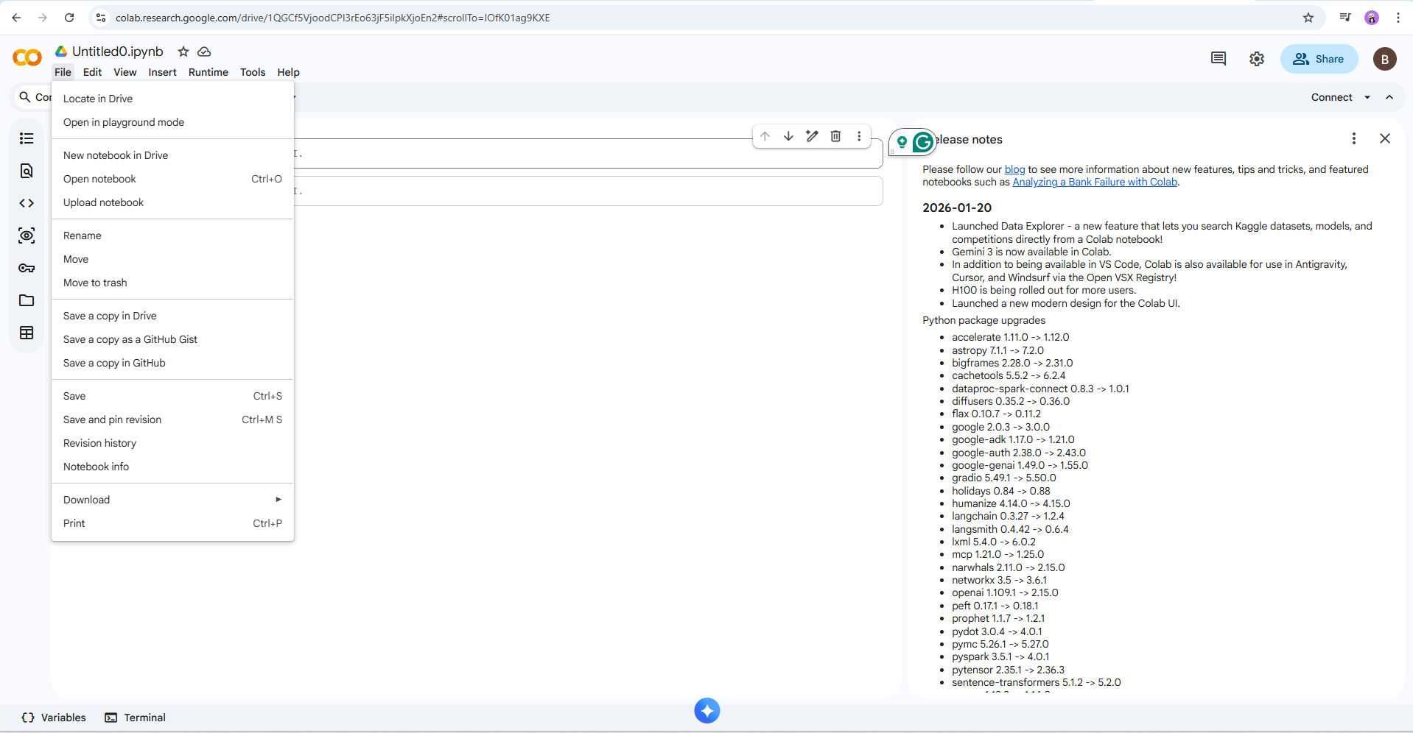
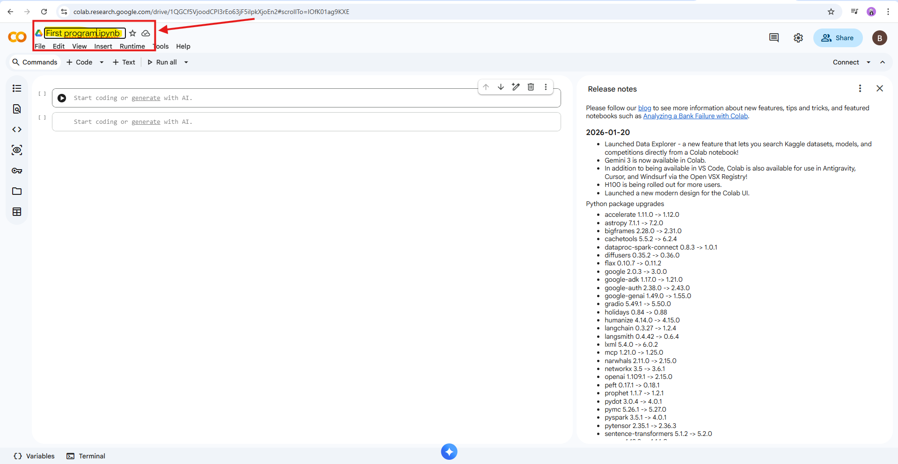
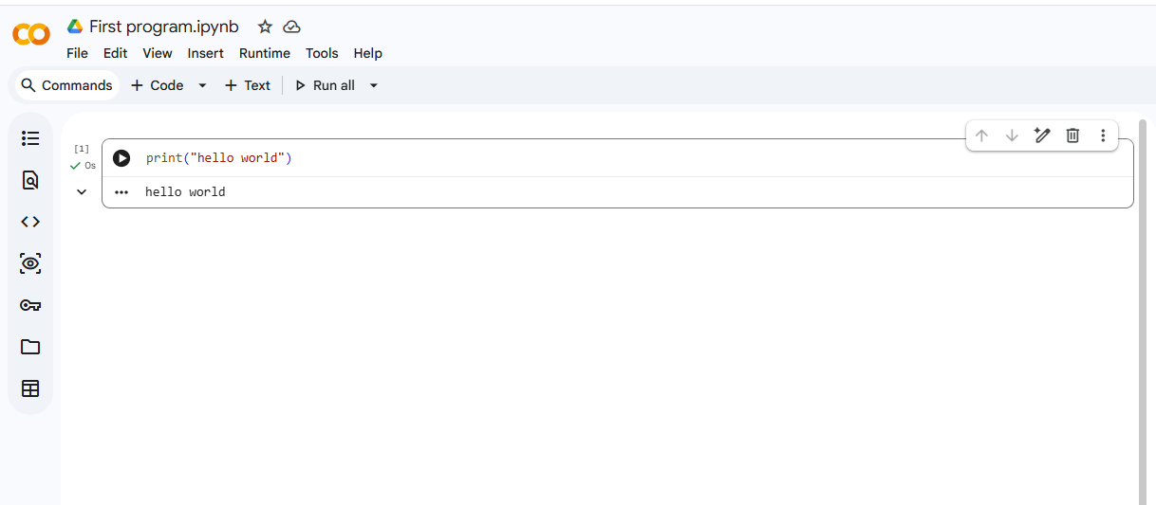

Overview of datasets

What is a Dataset in Data Mining?
A dataset is a structured collection of data used to discover patterns, relationships, or knowledge through data mining techniques.
In labs, datasets are usually stored as tables (rows = records, columns = attributes).

Common Types of Datasets

Structured Datasets
Data is organized in rows and columns.
Examples:
- Student performance data
- Sales transactions
- Bank customer records
Formats: CSV, Excel, SQL tables
Used for: Classification, clustering, regression

Transactional Datasets
Each record represents a transaction with a set of items.
Example:
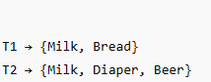
Used for:
- Association rule mining
- Market basket analysis
(Algorithms: Apriori, FP-Growth)

Time-Series Datasets
Data collected over time at regular intervals.
Examples:
- Stock prices
- Temperature readings
- Website traffic per day
Used for:
- Trend analysis
- Forecasting
- Sequential pattern mining

Spatial or Geographical Datasets
Data related to location or space.
Examples:
- GPS coordinates
- Maps
- Satellite images
Used for:
- Spatial clustering
- Location-based analysis

Text Datasets
Data in textual form.
Examples:
- Emails
- Reviews
- Tweets
Used for:
- Text mining
- Sentiment analysis
- Topic modeling

Web and Log Datasets
Data generated from web activity.
Examples:
- Clickstream data
- Server logs
- User browsing history
Used for:
- Web usage mining
- Recommendation systems

Attributes in a Dataset

1 Numerical Attributes
- Integer or real values
- Example: Age, Salary

2 Categorical Attributes
- Distinct categories
- Example: Gender, Department

3 Binary Attributes
- Two possible values
- Example: Yes/No, 0/1

How to download the dataset
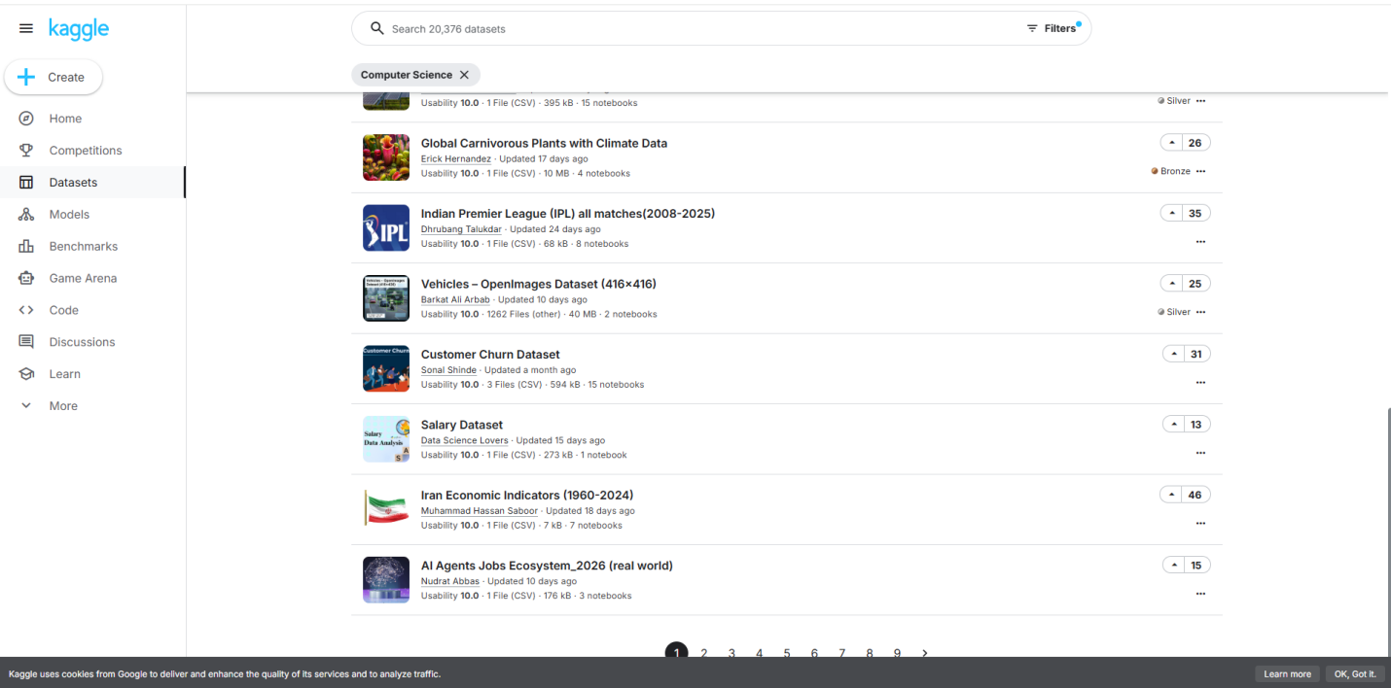

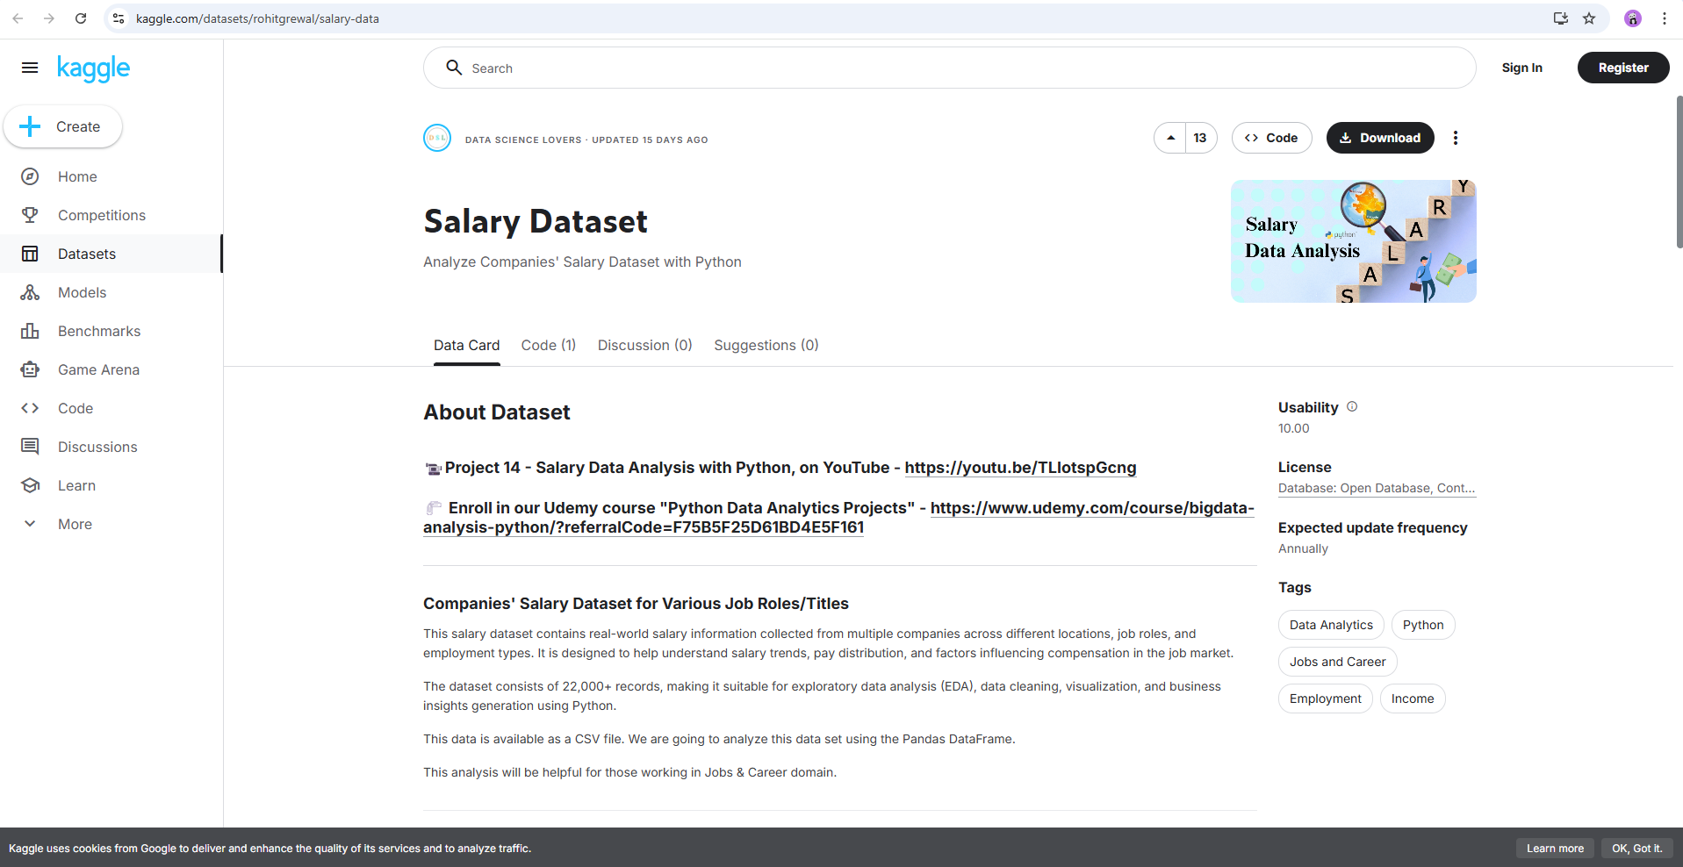
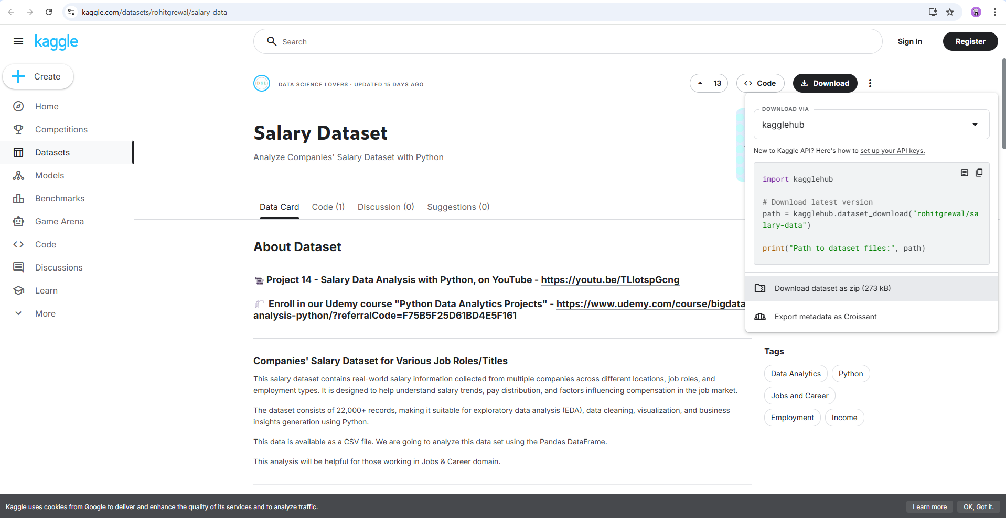
TASK:
Write a Python program that does the following:
- Create a list of integers entered by the user.
- Using a loop, go through each number in the list.
- For each number:
  - If the number is even, print "Even"
  - If the number is odd, print "Odd"
- At the end, print:
  - The total count of even numbers
  - The total count of odd numbers
INPUT

OUTPUT
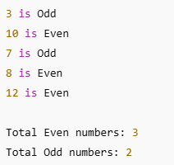
Introduction to Knime
KNIME (Konstanz Information Miner) is an open-source data analytics, reporting, and integration platform. It is designed to help users build data workflows visually, without heavy coding.

What is KNIME Used For?
KNIME is commonly used for:
- Data analysis
- Machine learning
- Data cleaning & preprocessing
- Data visualization
- Predictive modeling
- Business intelligence

Task 1:
Working on Iris Dataset:
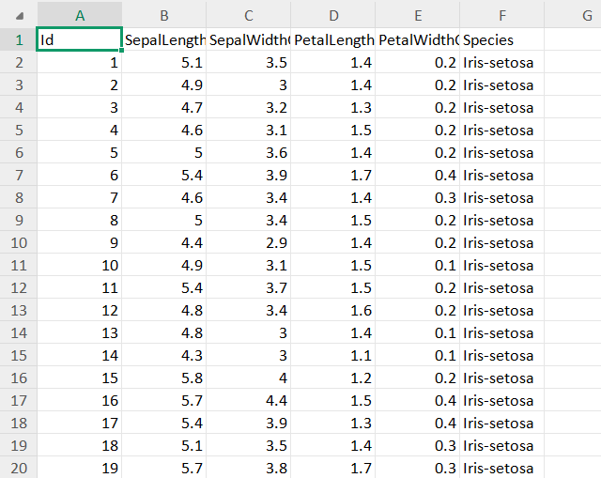
Calculating Sum, Count, Min, Max, Average, Mode:
By using the following formulas we calculate all these:
=COUNT(A1:A151)
=SUM(A1:A151)
=AVERAGE(A1:A151)
=MODE(B2:B151)
=MIN(A1:A151)
=MAX(A1:A151)
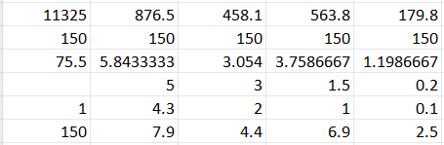
To form a table:
CTRL + T
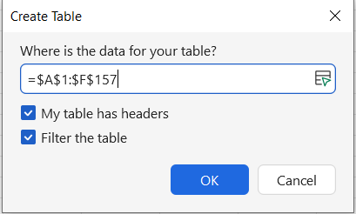
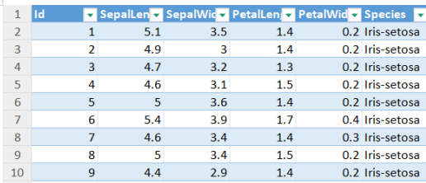
For highliting tables:
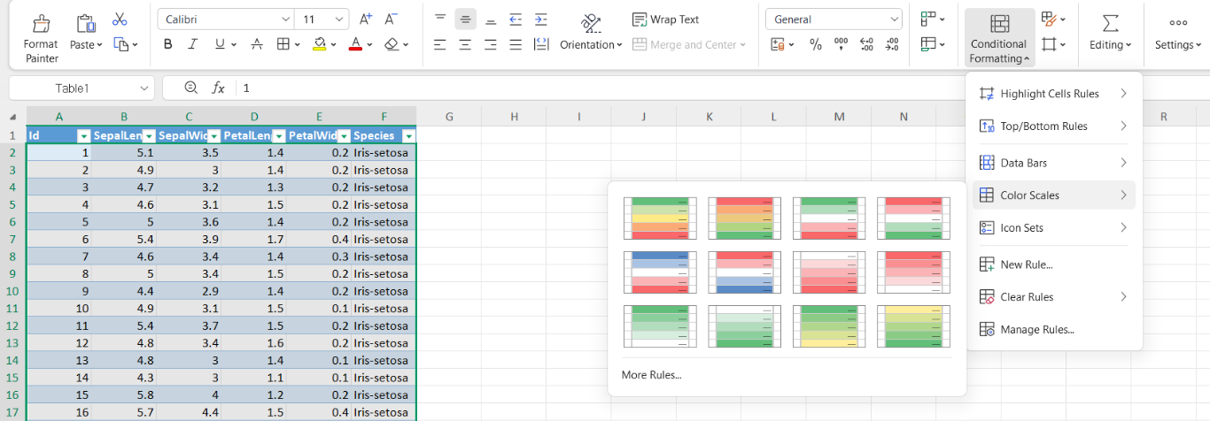

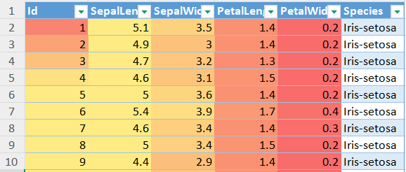

Working on knime
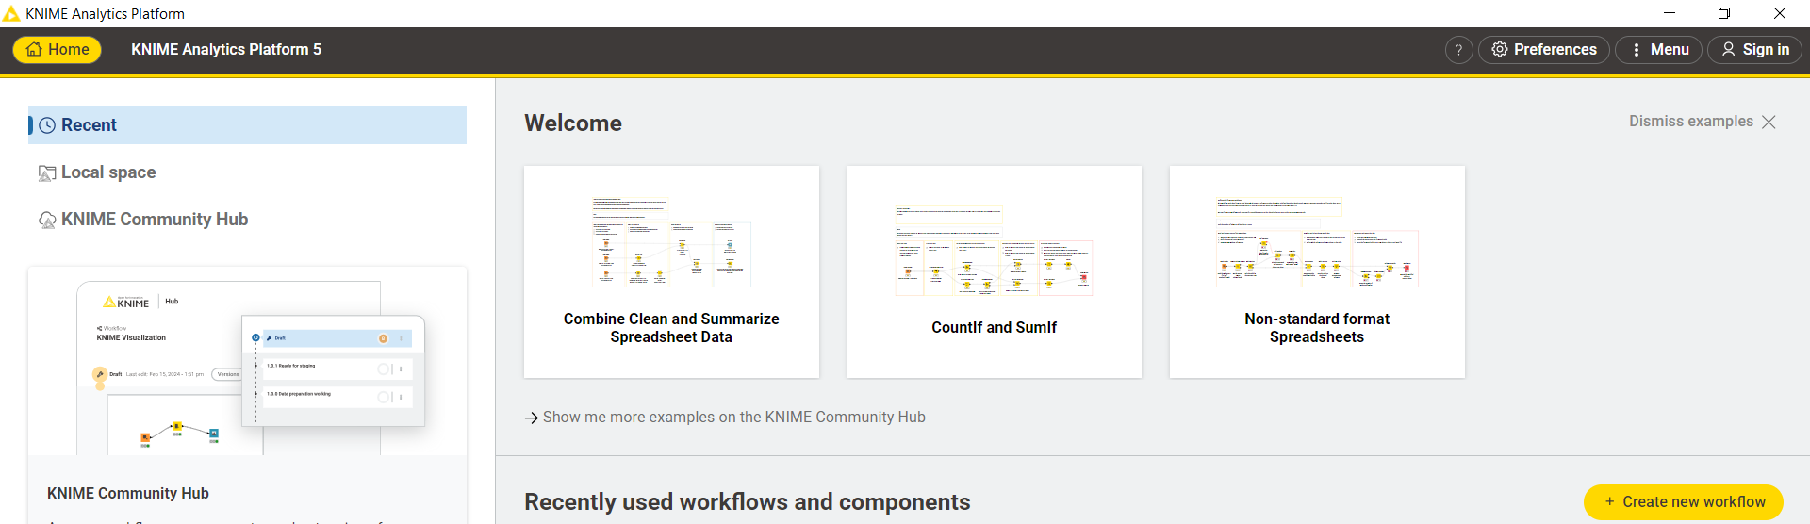

Click on create new workflow:
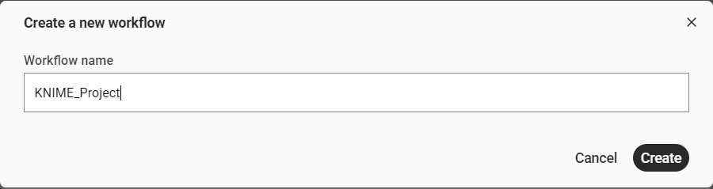

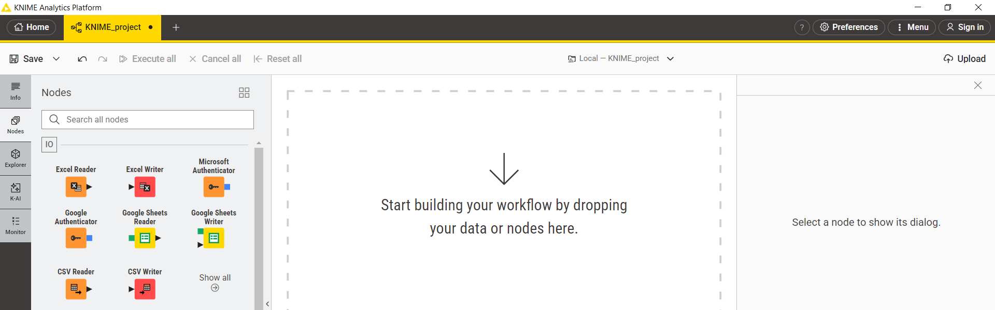

In Nodes section choose CSV reader:
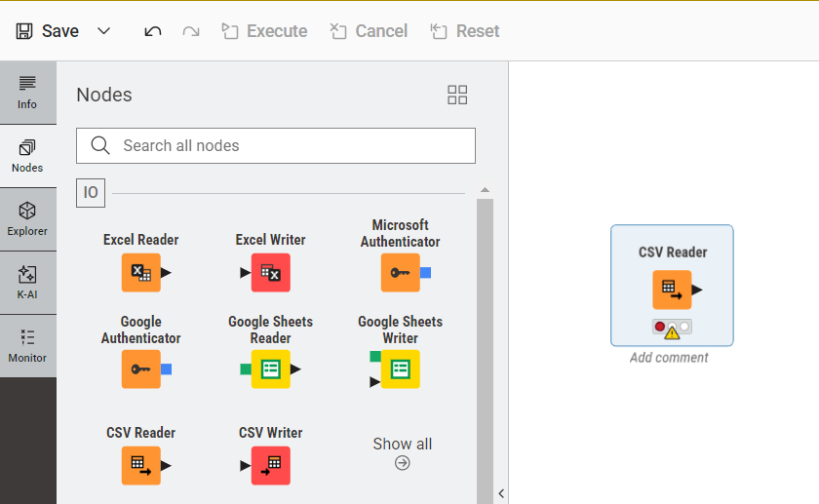
Browse the file u want to upload:
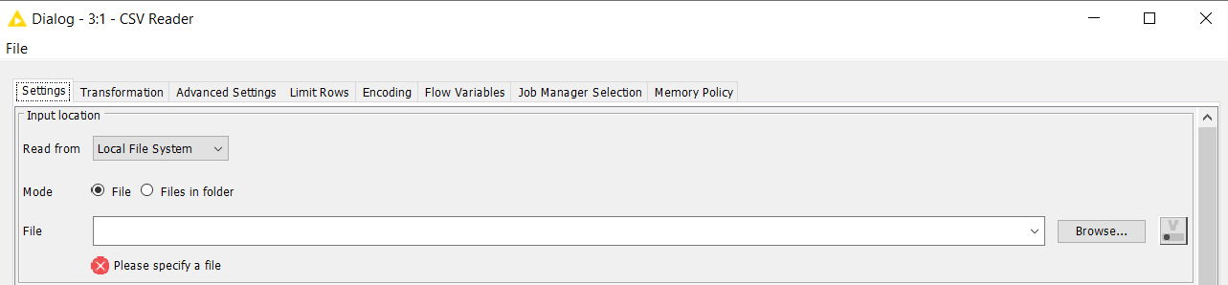

Select the file and click open:
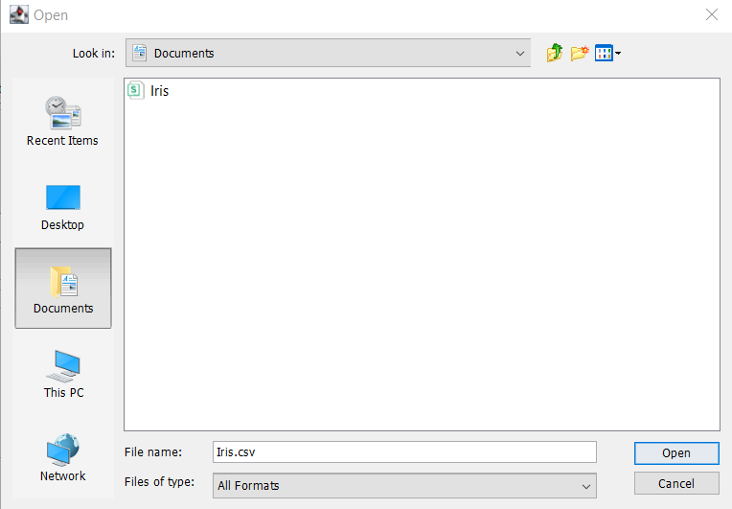

After clicking excute the CSV file will be uploaded in knime environment:
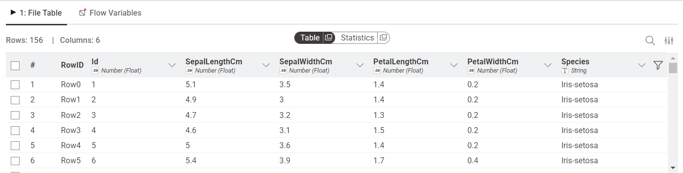

Now use statistic node:
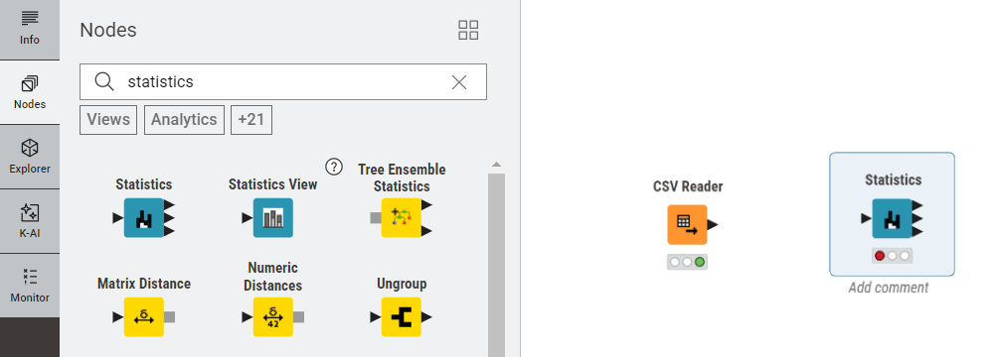

By joining it to the CSV node it will automatically display the mean, min, max, std dev etc.
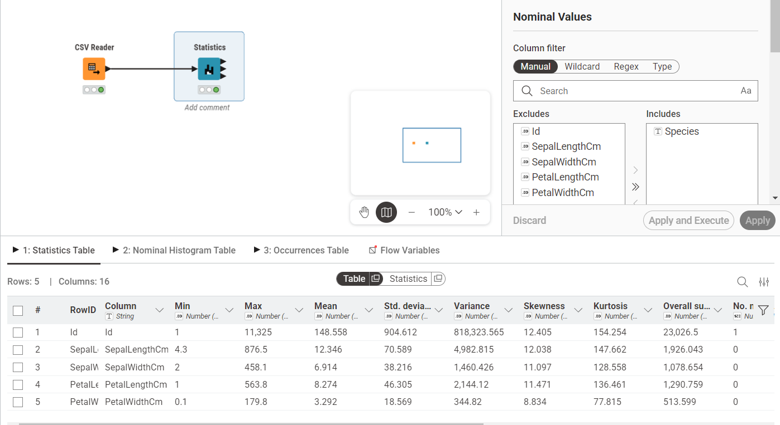

Now add barchart node:
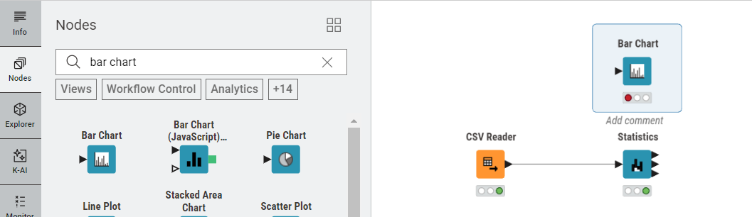

It will display the count of each specie:
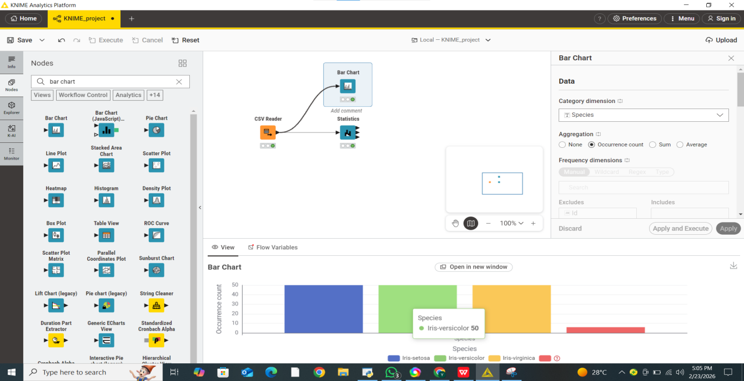

Now add the pie chart node:
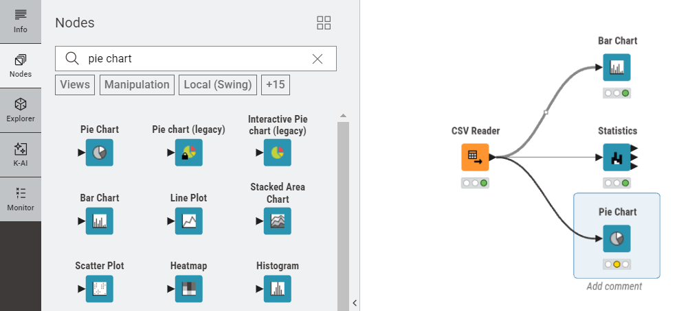
It will display the percentage of each specie in pie chart:
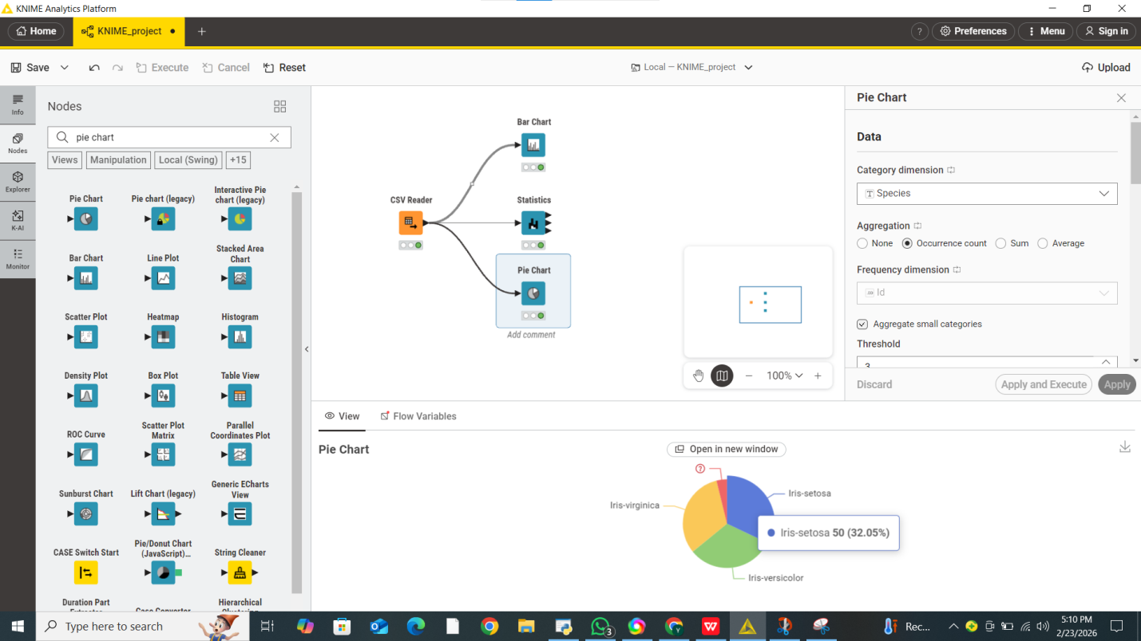

Now save the workflow:
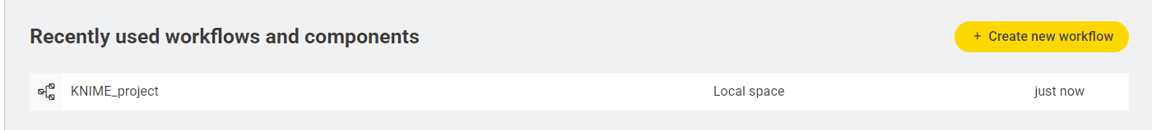

LAB-2

CRISP-DM Process And Data Types

CRISP-DM Process
CRISP-DM (Cross-Industry Standard Process for Data Mining) is a well-established framework used to guide data mining projects. It provides a clear, step-by-step structure to ensure an organized workflow. The process consists of six key stages: Business Understanding, Data Understanding, Data Preparation, Modeling, Evaluation, and Deployment.
- Business Understanding focuses on identifying the problem and setting clear objectives.
- Data Understanding involves gathering data and analyzing its characteristics.
- Data Preparation includes cleaning the dataset, transforming variables, and organizing it for analysis.
- Modeling is where appropriate algorithms are selected and applied to the data.
- Evaluation checks whether the model achieves the intended goals and performs effectively.
- Deployment is the final step, where the model is put into practical use.
For instance, in a sales forecasting project, CRISP-DM ensures a systematic process from defining the problem to implementing the final solution.

Types of Data
Data can be categorized based on its characteristics:
- Numerical Data includes measurable values and can be either discrete (e.g., number of items) or continuous (e.g., height or income).
- Categorical Data represents groups or labels and includes:
  - Nominal data (e.g., colors, names)
  - Ordinal data (e.g., rankings or levels)
- Binary Data consists of only two possible values, such as 0 and 1.
Recognizing the type of data is essential because different machine learning algorithms require specific input formats. For example, decision tree models can easily work with categorical variables, while linear regression models typically require numerical inputs.

Real-World Applications
Data mining plays a significant role in many industries:
- In healthcare, it is used for predicting diseases and assisting in diagnosis.
- In retail, it supports recommendation systems and analyzes customer purchasing patterns.
- In finance, it helps identify fraudulent activities and manage financial risks.
- On social media platforms, it is applied in sentiment analysis and personalized advertising.
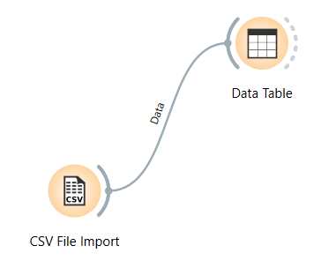
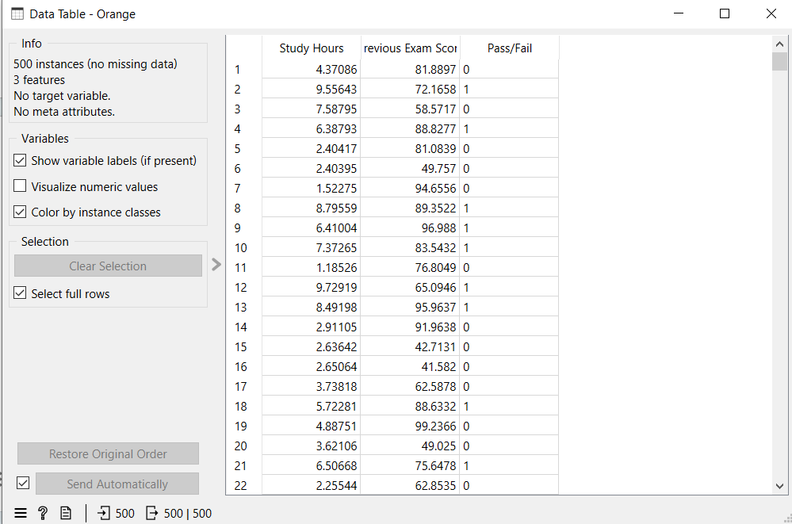
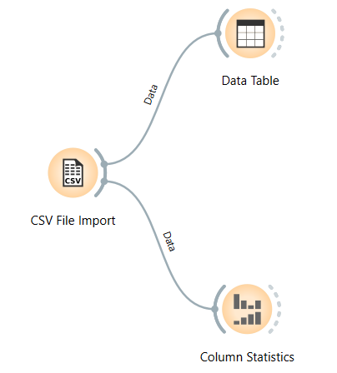
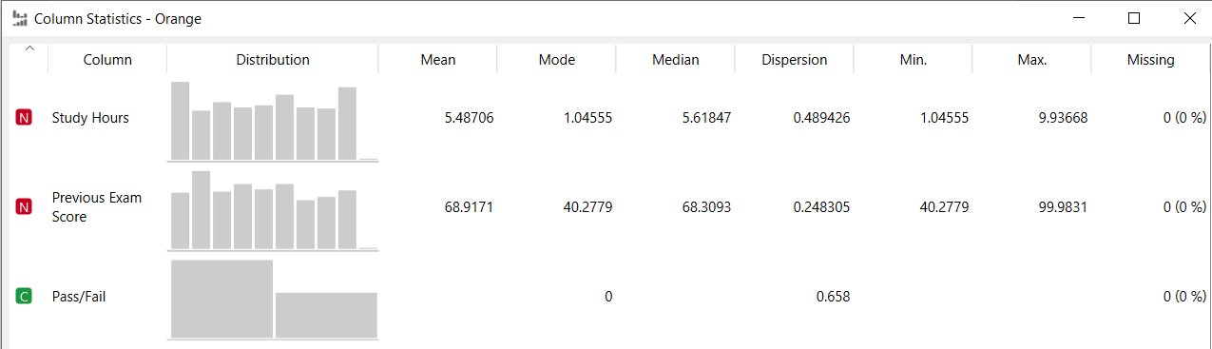
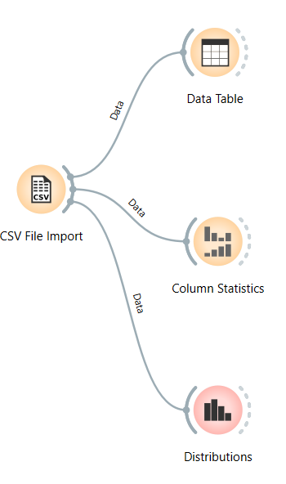
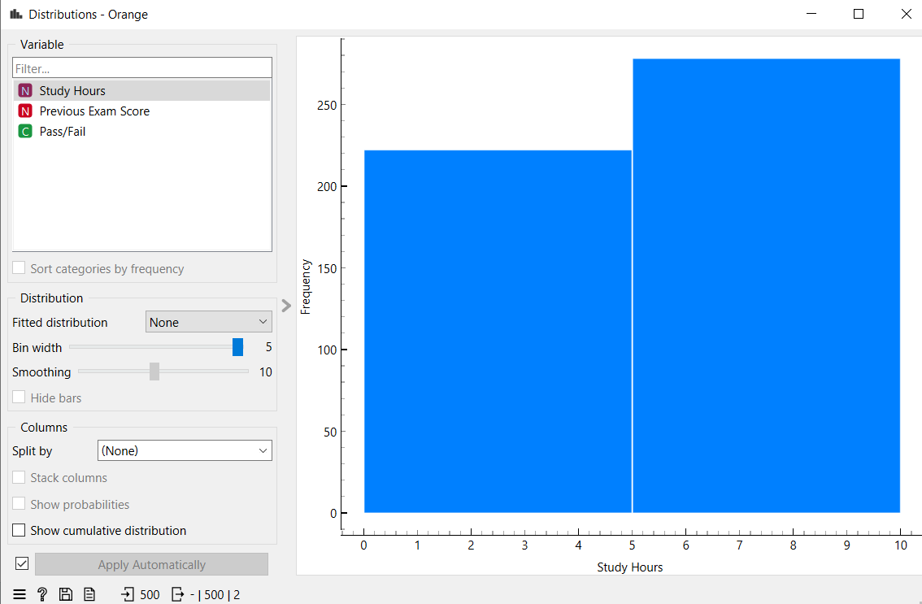

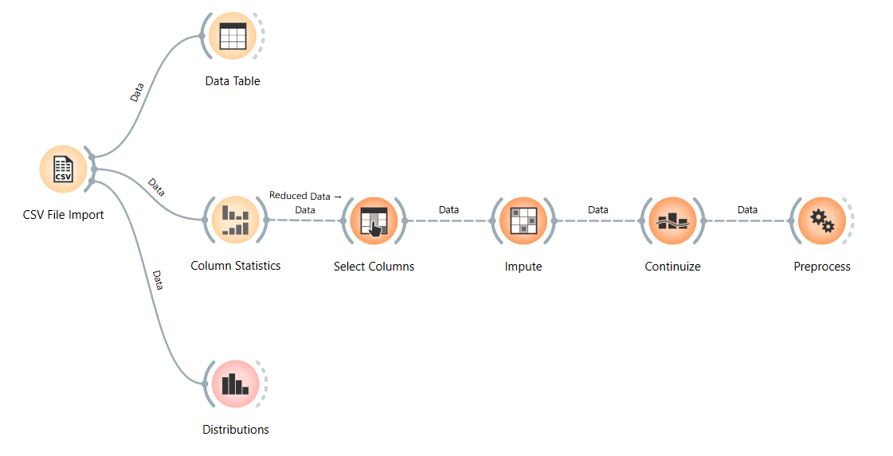
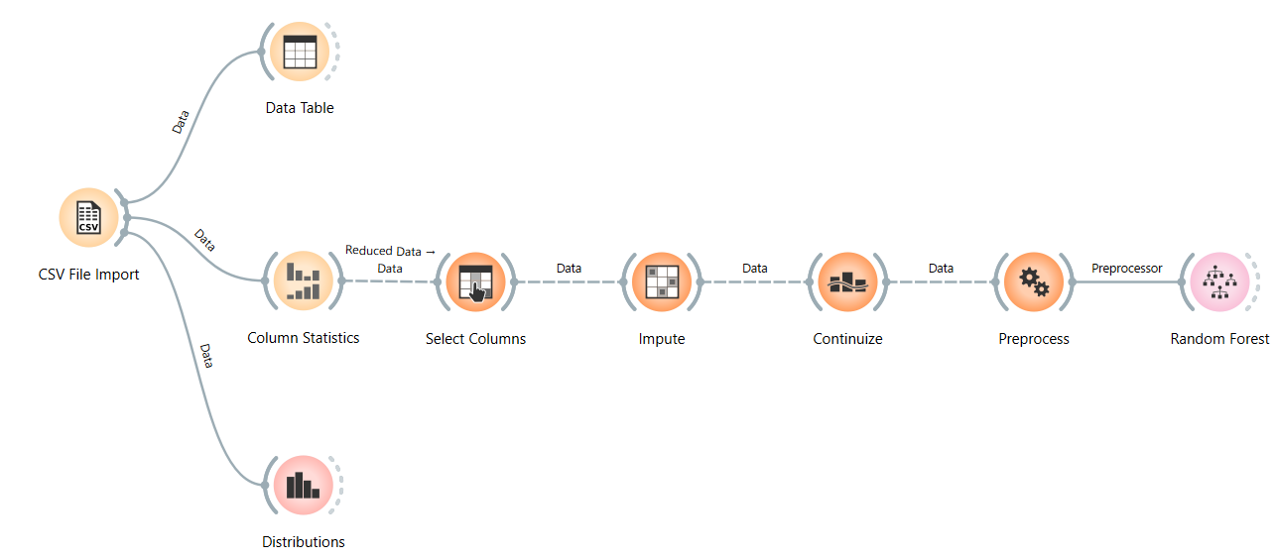
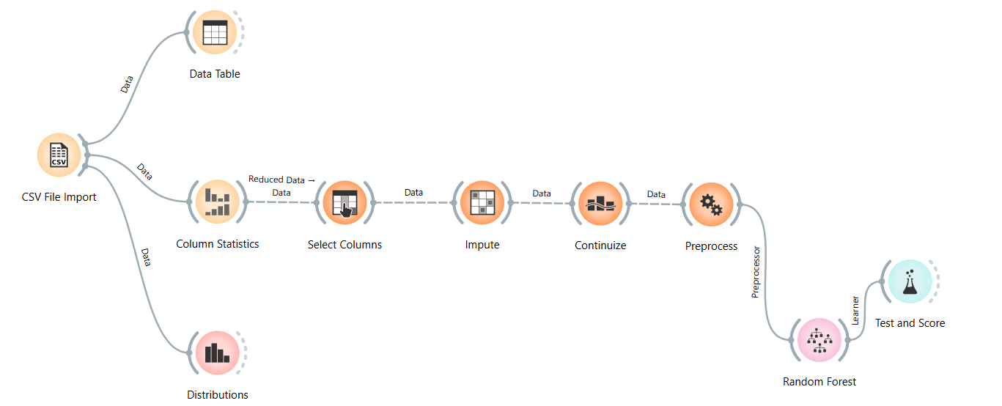
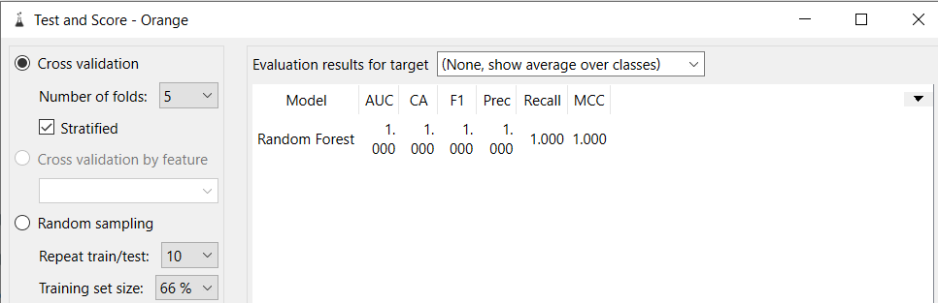

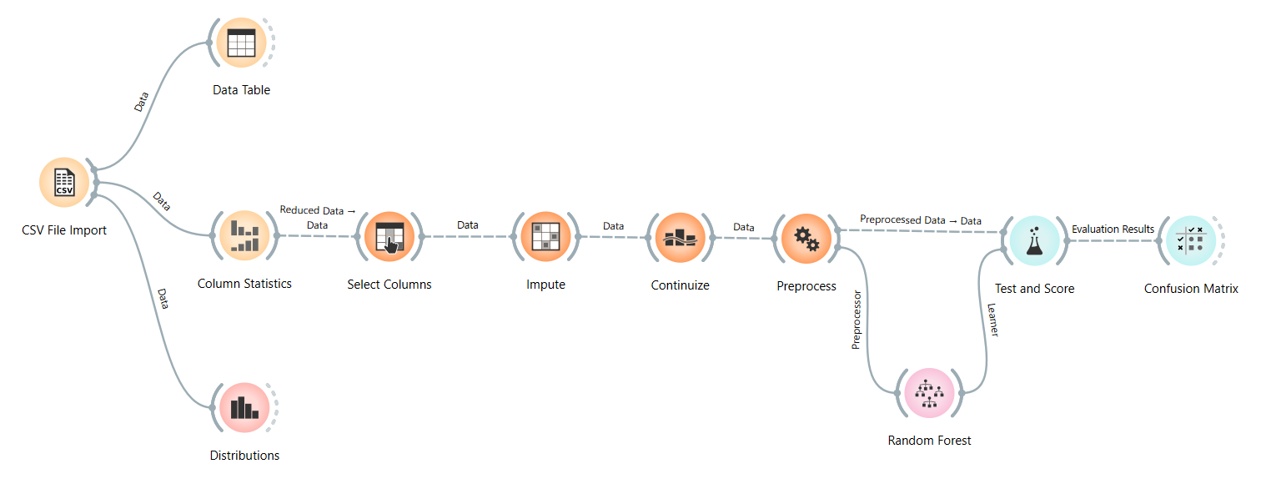
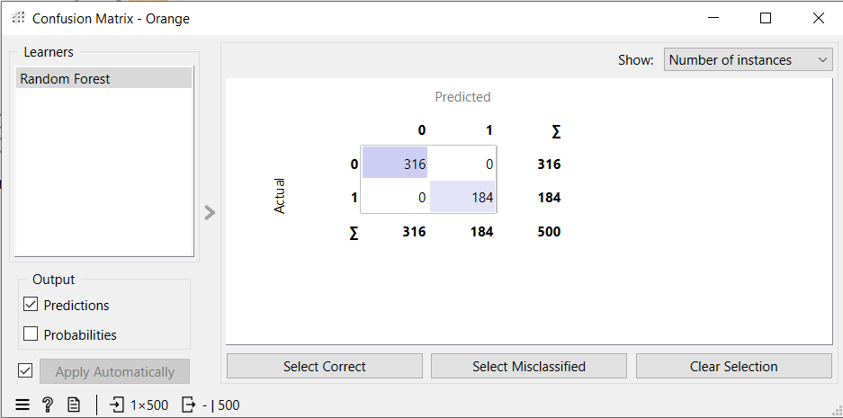
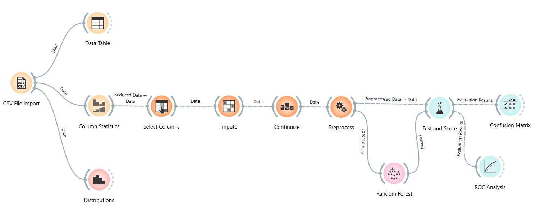
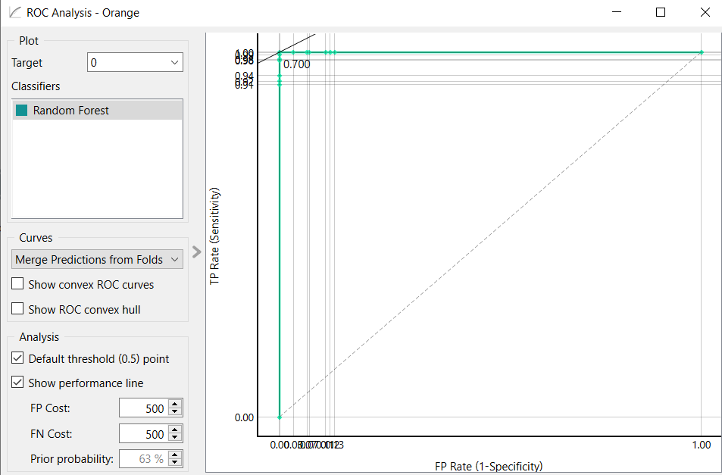
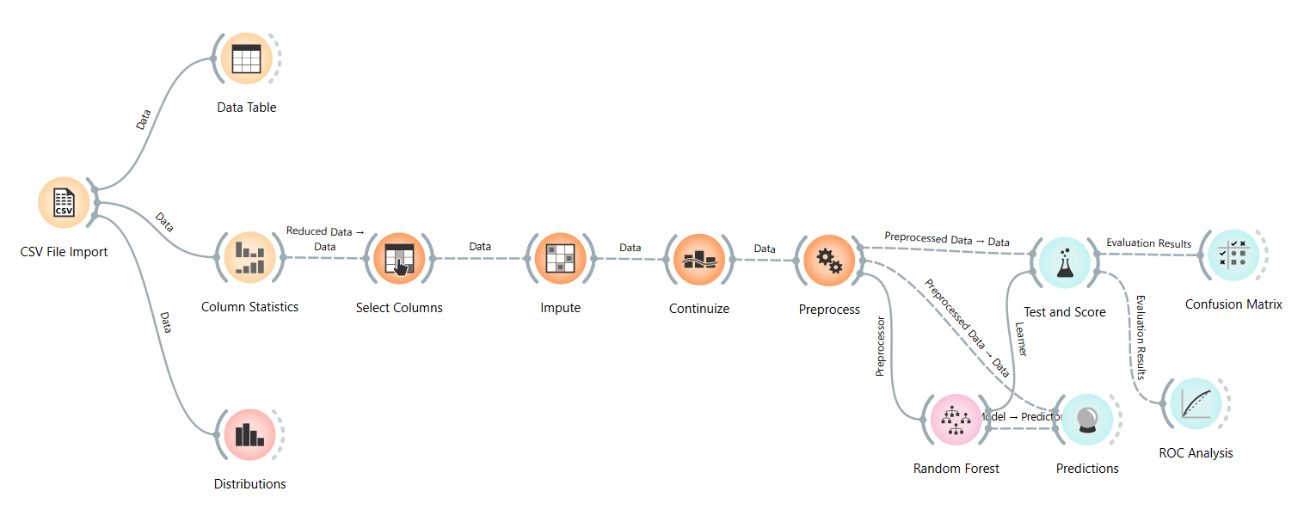
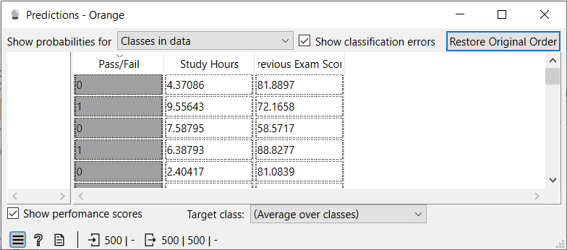

LAB-3
Data Cleaning Techniques

Handling Missing Values
Missing data appears when certain values are not recorded in a dataset, which can negatively impact analysis and model accuracy. To address this issue, simple methods such as removing records with missing entries or replacing them with statistical measures like the mean, median, or mode are commonly used. More advanced approaches include techniques like interpolation or using machine learning models to estimate the missing values. For instance, if the age field is missing for some entries, it can be filled using the average age calculated from the available data.

Removing Duplicates
Duplicate entries occur when identical records are present more than once in a dataset. These repetitions can distort analysis and produce misleading results. Therefore, it is important to detect and eliminate duplicates during the data preprocessing stage. For example, if the same customer information is recorded multiple times, the extra copies should be removed to ensure data accuracy and consistency.

Handling Noise Using Python
Noise in data refers to random errors or irregular variations that can reduce the quality of analysis. It can be minimized using methods such as smoothing, binning, regression techniques, or filtering. Python tools like Pandas and NumPy offer useful functions to clean and refine noisy datasets. For example, extreme values (outliers) in salary data can be identified and removed to achieve more reliable analytical results.
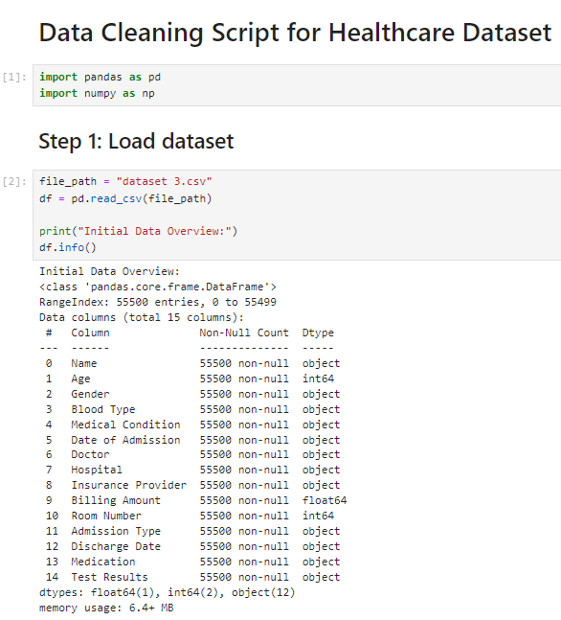
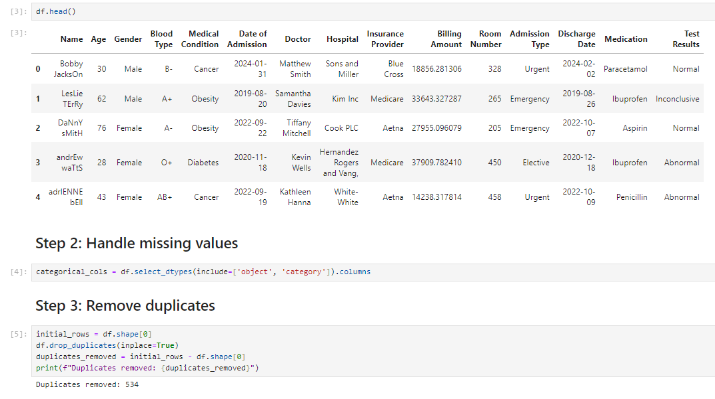

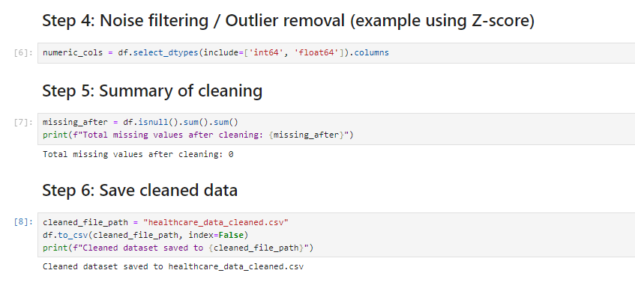

LAB-4
Data Preprocessing

Normalization
Normalization is a technique used to rescale data so that all values fall within a specific range, typically between 0 and 1. This is especially helpful when different features have varying scales, as it ensures consistency across the dataset.
The formula used is:
(X−Min)/(Max−Min)(X - \text{Min}) / (\text{Max} - \text{Min})(X−Min)/(Max−Min)
For example, features like salary and age can be normalized so they are comparable within the same range.

Standardization
Standardization adjusts data so that it has a mean of 0 and a standard deviation of 1. This transformation is useful for many machine learning algorithms that assume normally distributed data.
The formula is:
(X−Mean)/Standard Deviation(X - \text{Mean}) / \text{Standard Deviation}(X−Mean)/Standard Deviation
It is widely applied in algorithms such as Support Vector Machines (SVM) and K-Nearest Neighbors (KNN).

Discretization
Discretization is the process of converting continuous variables into distinct categories or intervals. This method simplifies data and can make patterns easier to identify.
For instance, age values can be grouped into categories like young, adult, and elderly. This can also enhance the performance of certain models.

Summary Statistics
Summary statistics provide a quick overview of the key characteristics of a dataset. Common measures include mean, median, mode, variance, and standard deviation.
These statistics help in understanding the overall distribution, central tendency, and variability within the data.

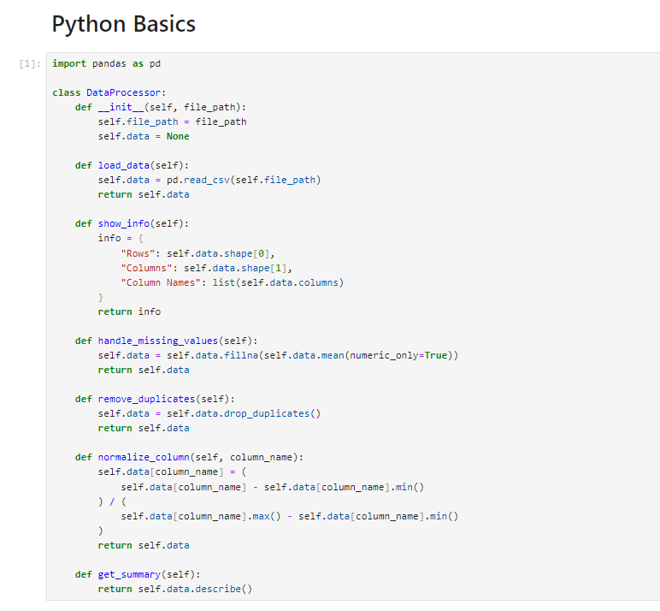
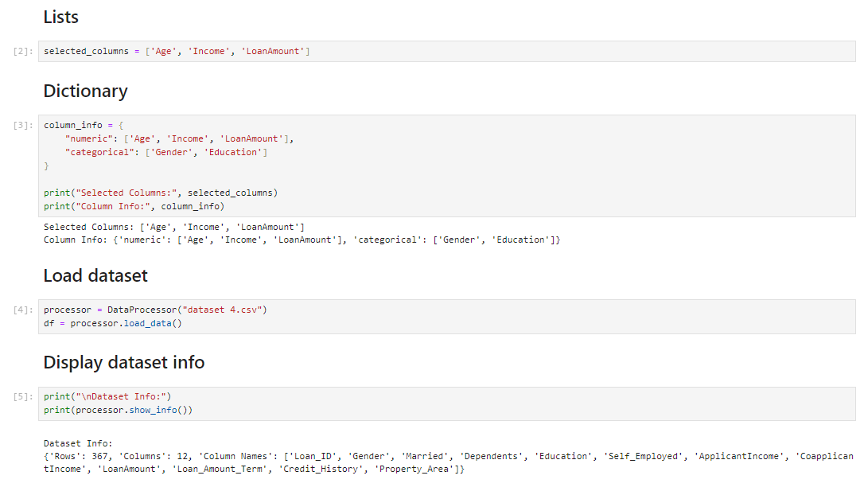
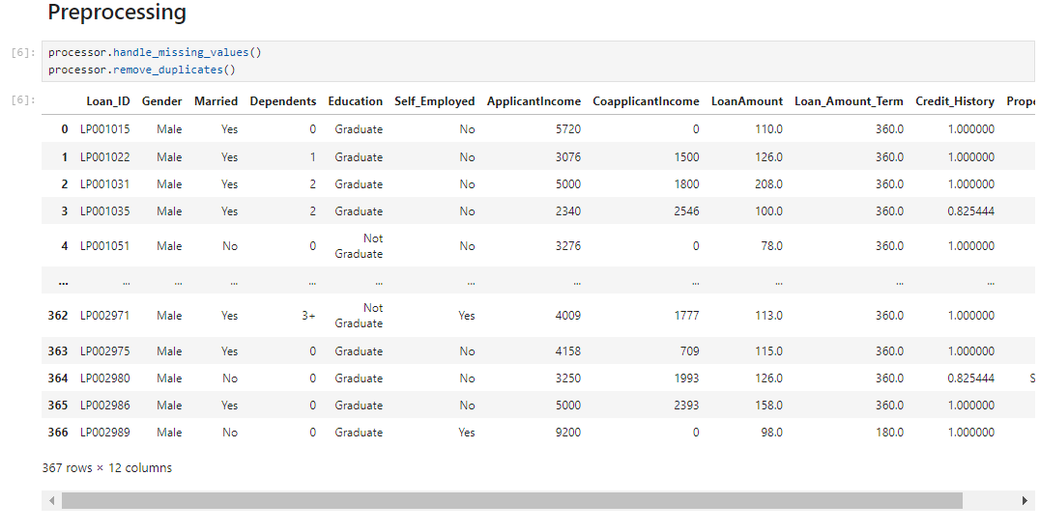

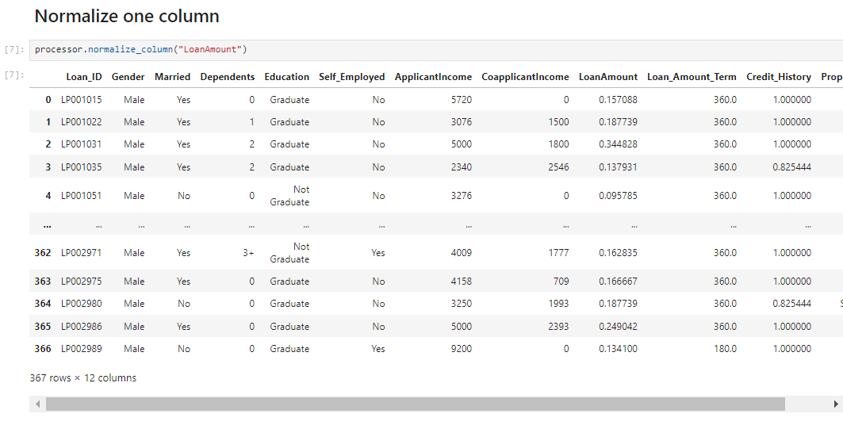
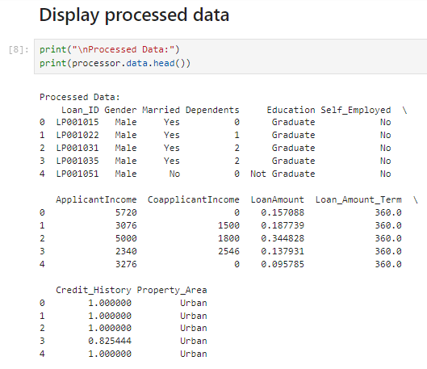

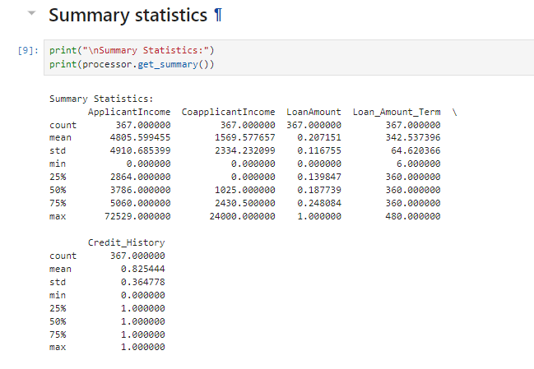

LAB-5
Market Based Analysis

Market Basket Analysis
Market Basket Analysis is a data mining technique used to discover patterns in customer purchases by identifying items that are frequently bought together. It helps businesses gain insights into consumer behavior and improve strategies such as product placement and recommendations. For example, if customers frequently purchase bread along with butter, this relationship can be used to increase sales through promotions or product bundling.

Support
Support indicates how often a particular item or combination of items appears in a dataset. It reflects the overall popularity of an itemset within all transactions.
The formula is:
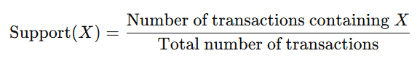

Confidence
Confidence measures the probability that a customer will purchase item Y given that they have already purchased item X. It helps evaluate the strength of an association rule.
The formula is:
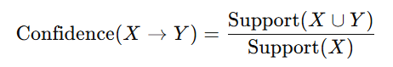

Lift
Lift evaluates how strongly two items are associated compared to what would be expected if they were independent. It indicates whether the occurrence of one item increases or decreases the likelihood of the other.The formula is:
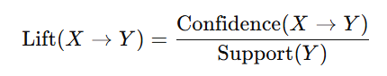
- If Lift > 1, the items have a positive association.
- If Lift < 1, the items are negatively related.
- If Lift = 1, there is no relationship between the items.
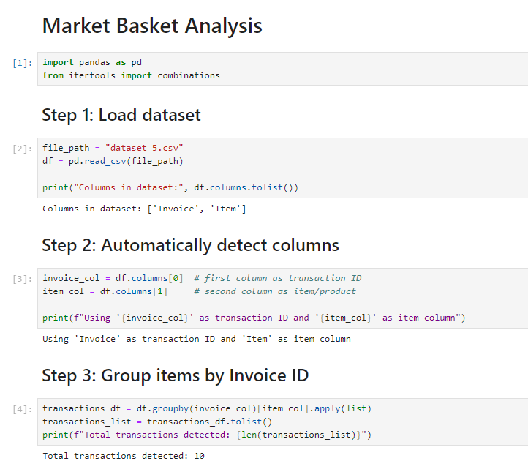

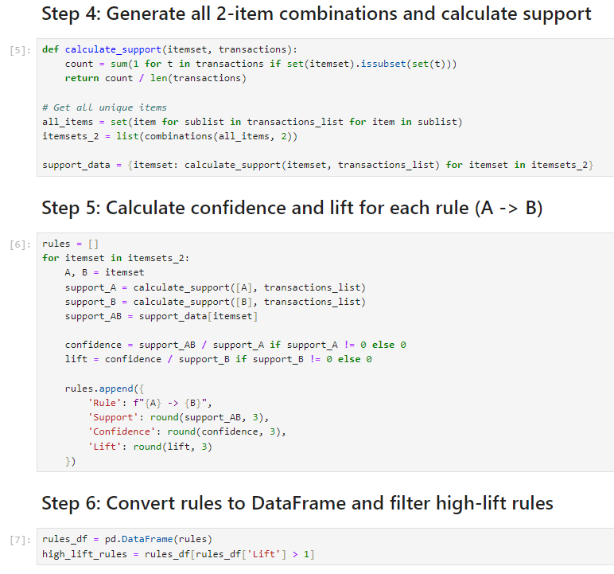

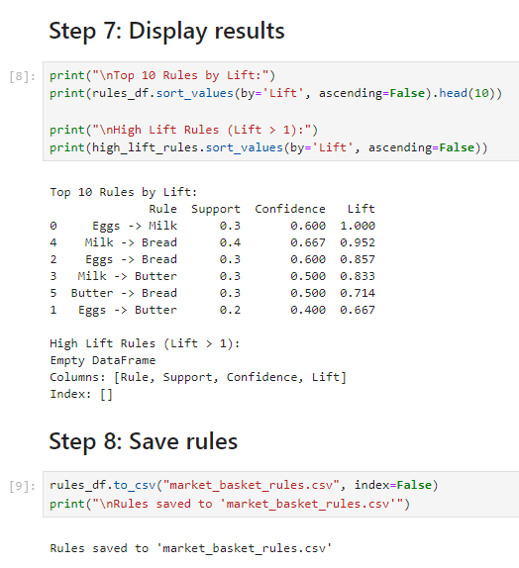

LAB-6
Apriori Algoritm

Apriori Algorithm
The Apriori algorithm is a widely used technique for discovering frequent itemsets within transactional datasets. It is based on the idea that if an itemset is frequent, then all of its subsets must also be frequent.
The algorithm works by first generating possible item combinations (candidate itemsets) and then eliminating those that do not meet a specified minimum support threshold. This iterative process continues until all frequent itemsets are identified.

Frequent Itemset Generation
Frequent itemsets refer to combinations of items that commonly occur together in a dataset. These itemsets play a key role in forming association rules that reveal relationships between products or events.
For example, a combination like {Milk, Bread} may appear often in transactions, making it a frequent itemset.

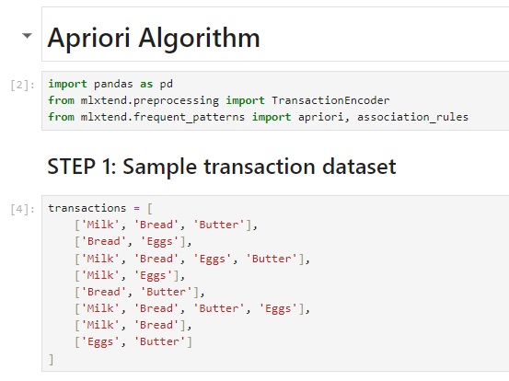
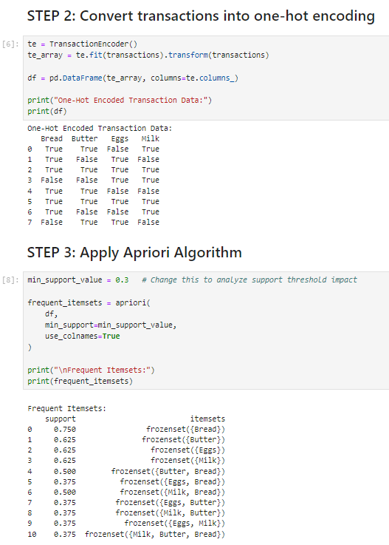

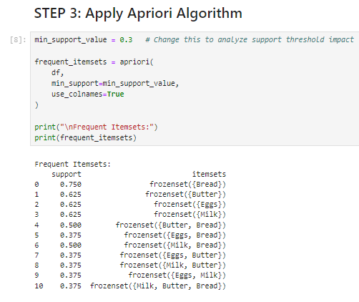
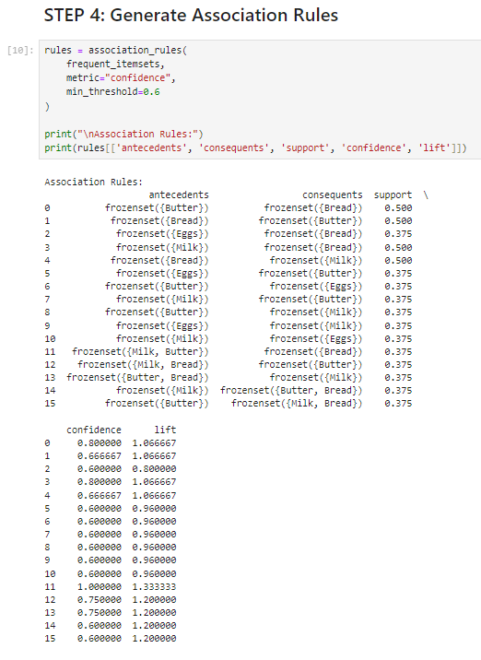

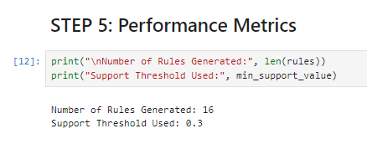

LAB-7
FP Tree And FP Growth

FP-Tree
An FP-Tree (Frequent Pattern Tree) is a compressed representation of transactional data used in frequent pattern mining. Instead of storing all transactions separately, it organizes them in a tree structure where common item prefixes are shared, making the representation more efficient. The construction of an FP-Tree involves two main steps. First, the dataset is scanned to identify frequent items based on a minimum support threshold. Then, transactions are reordered according to the frequency of items and inserted into the tree, combining overlapping paths wherever possible.
This approach significantly reduces storage requirements and eliminates the need to generate large numbers of candidate itemsets, which is a limitation in methods like Apriori.

FP-Growth Algorithm
The FP-Growth (Frequent Pattern Growth) algorithm is used to mine frequent itemsets directly from the FP-Tree. It is considered more efficient than the Apriori algorithm because it avoids repeated scanning of the database and does not rely on candidate generation.
The algorithm works using a divide-and-conquer strategy. It breaks the problem into smaller subproblems by creating conditional pattern bases and conditional FP-Trees for each item. These smaller trees are then mined recursively to extract frequent patterns.
Due to its efficiency and scalability, FP-Growth is particularly useful when working with large datasets where traditional algorithms may become slow or computationally expensive.
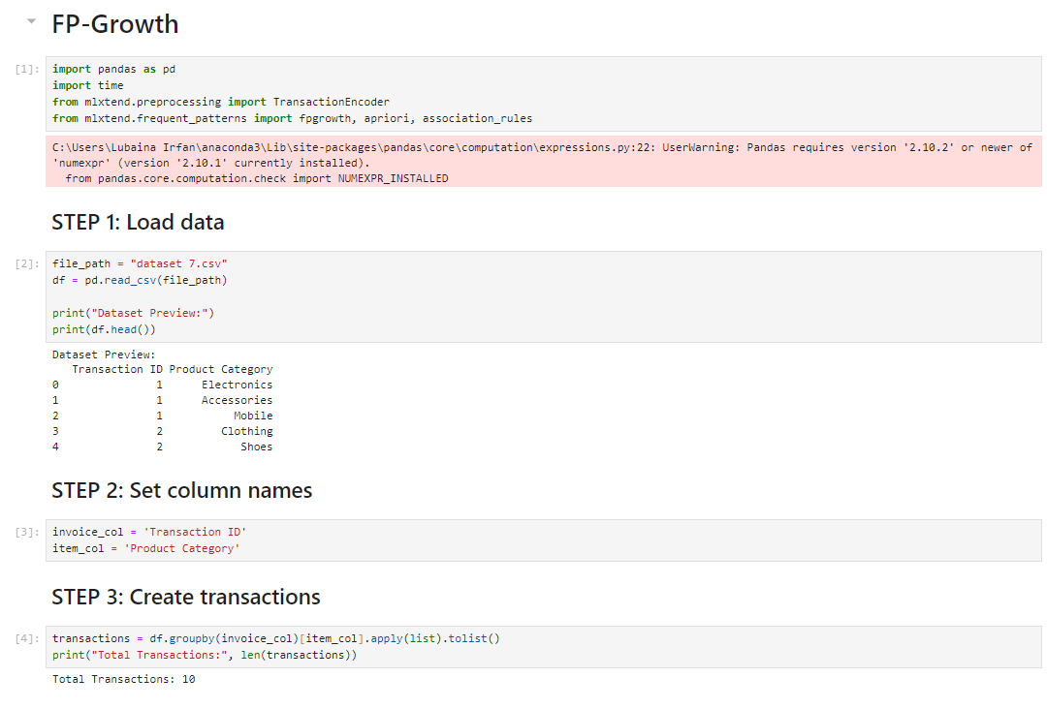
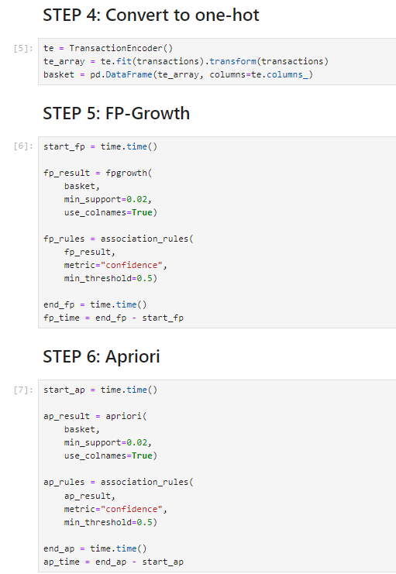

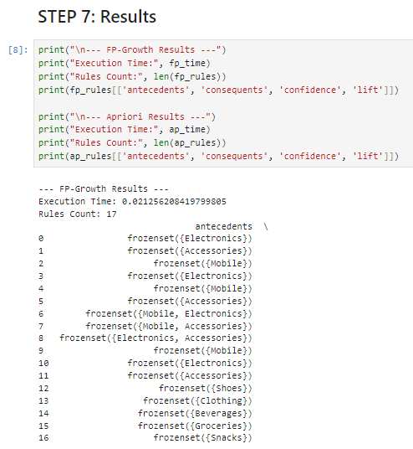
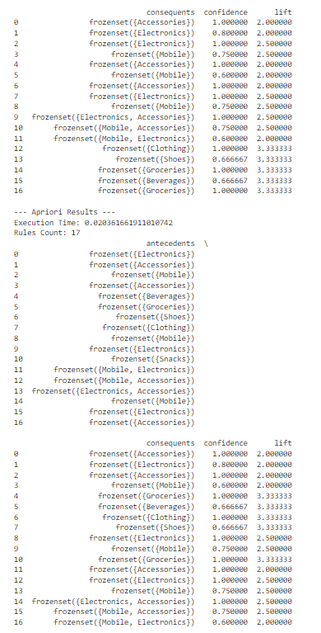

LAB-8
Python Basics For Data Mining

Python Syntax
Python is a widely used programming language known for its simplicity and versatility, especially in data mining and data analysis. One of its key features is that it relies on indentation to define code blocks instead of using braces.
For example:
print('Hello World')

Lists and Dictionaries
Lists are used to store a sequence of elements in a specific order. They can hold different data types and are written using square brackets.
Example:
[1, 2, 3]
Dictionaries, on the other hand, store data in the form of key-value pairs, allowing quick access to values based on their keys. They are written using curly braces.
Example:
{'name': 'Ali', 'age': 20}

Object-Oriented Programming (OOP) Basics
Object-Oriented Programming is a programming approach that organizes code using classes and objects. It includes important concepts such as inheritance, encapsulation, and polymorphism.

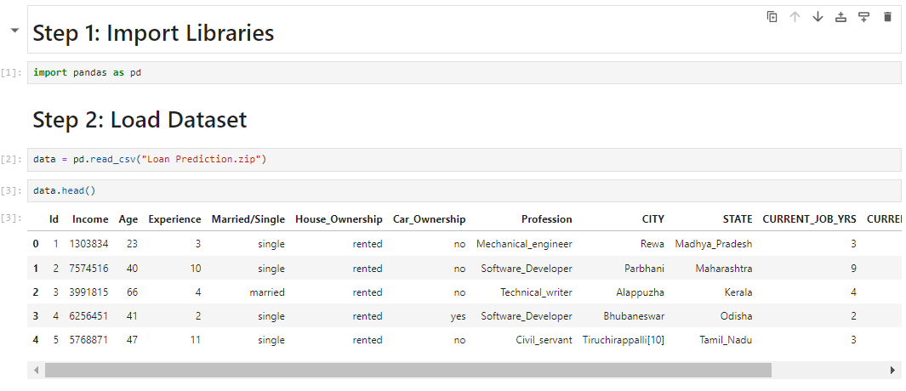
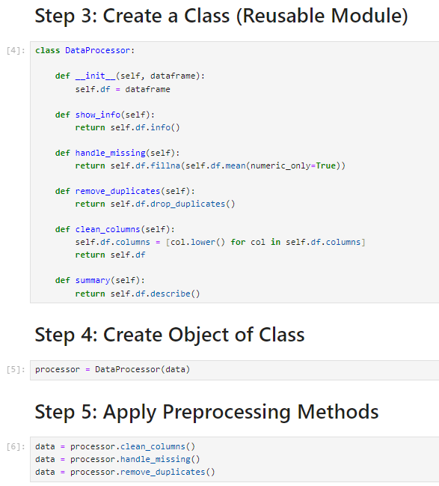
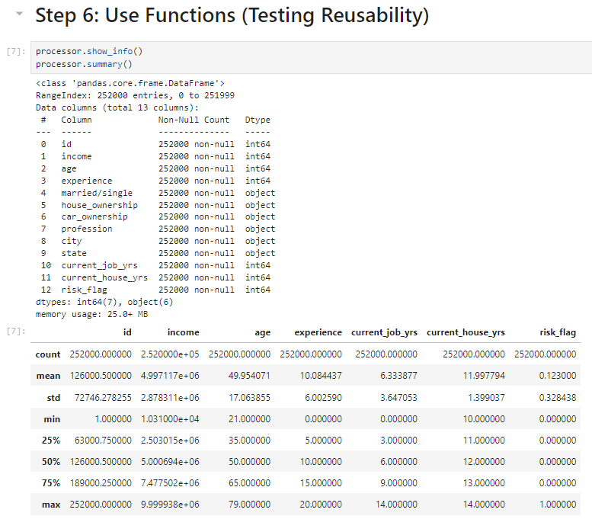
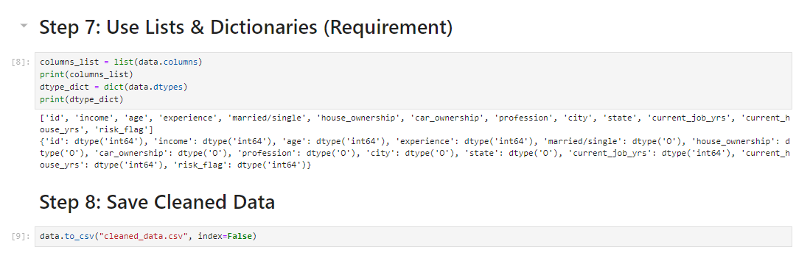

LAB-9
Decision Tree
A Decision Tree is a supervised machine learning algorithm used for classification and regression tasks. It is one of the most simple and widely used algorithms because of its easy interpretation and visualization.
The model works like a tree structure, where:
- Each internal node represents a decision based on a feature (attribute)
- Each branch represents the outcome of that decision
- Each leaf node represents the final prediction or class label
In a Decision Tree, the dataset is repeatedly split into smaller subsets based on the most important features. The goal is to create pure subsets, meaning that the data in each subset belongs to a single class as much as possible.

Working Principle
The algorithm selects the best feature to split the data at each step using measures such as:
Information Gain
Gini Index
These measures help determine which feature best separates the data into distinct classes. The process continues recursively until:
- All data points belong to the same class, or
- A stopping condition is reached (e.g., maximum depth)

Types of Decision Trees
- Classification Tree – Used when the target variable is categorical (e.g., Yes/No, Buy/Not Buy)
- Regression Tree – Used when the target variable is continuous (e.g., price, income)

Advantages
- Easy to understand and interpret
- Requires little data preprocessing
- Can handle both numerical and categorical data
- Provides clear decision rules

Disadvantages
- Prone to overfitting if not controlled
- Can become complex with large datasets
- Small changes in data can lead to different trees

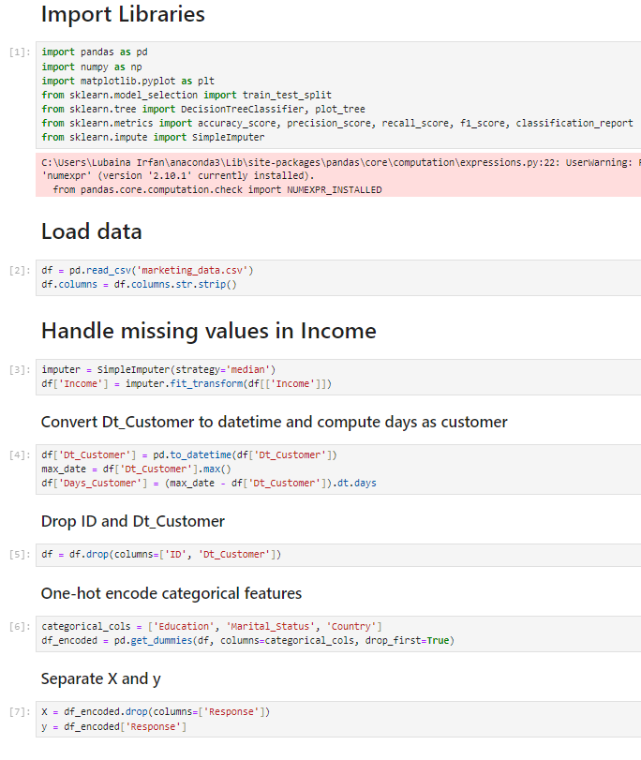
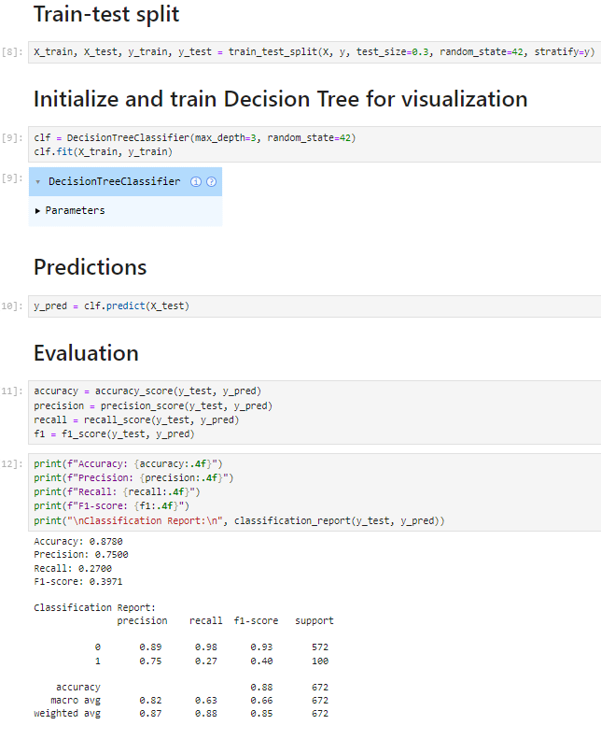\
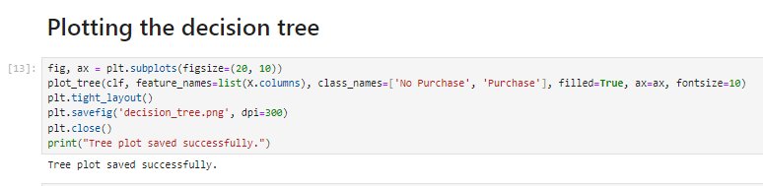

LAB-10
Naïve Bayes & KNN
1. Naïve Bayes Classifier

Introduction
Naïve Bayes is a probabilistic machine learning algorithm based on Bayes’ Theorem. It is mainly used for classification problems, especially when dealing with large datasets and text data (e.g., spam detection, sentiment analysis).

Bayes’ Theorem
The foundation of Naïve Bayes is:
[
P(C|X) = \frac{P(X|C)\cdot P(C)}{P(X)}
]
Where:
- (P(C|X)) = Posterior probability (probability of class given input)
- (P(X|C)) = Likelihood (probability of input given class)
- (P(C)) = Prior probability of class
- (P(X)) = Evidence (constant for all classes)

Working Principle
Naïve Bayes assumes that all features are independent of each other (this is the “naïve” assumption).
Steps:
- Calculate prior probability for each class.
- Compute likelihood of features given each class.
- Apply Bayes’ theorem to calculate posterior probability.
- Assign the class with the highest probability.

Types of Naïve Bayes
- Gaussian Naïve Bayes – for continuous data
- Multinomial Naïve Bayes – for discrete data (e.g., word counts)
- Bernoulli Naïve Bayes – for binary features

Advantages
- Simple and fast
- Works well with high-dimensional data
- Performs well on text classification

Disadvantages
- Assumes feature independence (rare in real-world data)
- May perform poorly if this assumption is violated

Applications
- Email spam filtering
- Sentiment analysis
- Document classification
- Medical diagnosis

2. K-Nearest Neighbors (KNN)

Introduction
KNN is a non-parametric, instance-based learning algorithm used for both classification and regression. It classifies a data point based on how its neighbors are classified.

Working Principle
KNN stores all training data and makes predictions based on similarity.
Steps:
- Choose a value of K (number of neighbors).
- Calculate distance between the new data point and all training points.
- Select the K nearest neighbors.
- Assign the class based on:
  - Majority voting (classification)
  - Average value (regression)

Distance Metrics
Common methods to measure distance:
- Euclidean Distance
[
d = \sqrt{\sum (x_i - y_i)^2}
]
- Manhattan Distance
- Minkowski Distance

Choosing K Value
- Small K → sensitive to noise
- Large K → smoother decision boundary
- Optimal K is usually found using validation

Advantages
- Simple and easy to understand
- No training phase (lazy learner)
- Works well with small datasets

Disadvantages
- Computationally expensive for large datasets
- Sensitive to irrelevant features
- Requires feature scaling

Applications
- Pattern recognition
- Recommendation systems
- Image classification
- Medical diagnosis

3. Key Differences Between Naïve Bayes and KNN
Feature | Naïve Bayes | KNN
Type | Probabilistic | Distance-based
Training | Fast | No training phase
Prediction | Fast | Slow (computes distance)
Assumption | Feature independence | No assumption
Data Size | Works well with large data | Better for small datasets

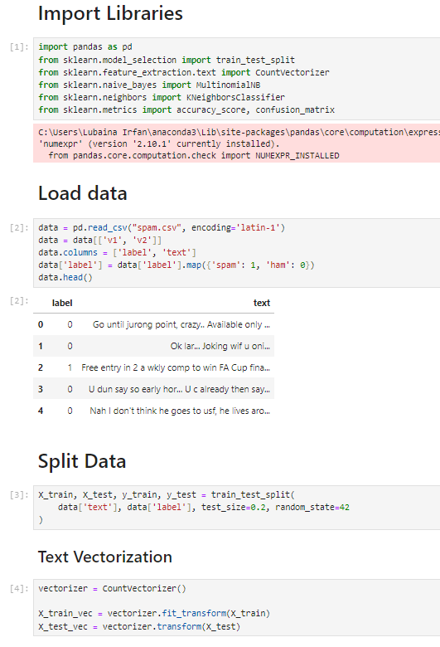
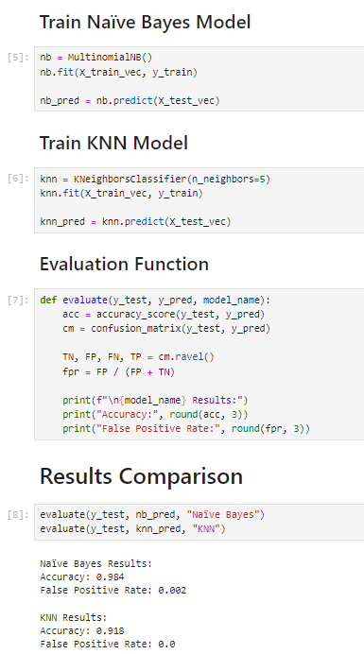

LAB-11
Support Vector Machine

. Introduction
Support Vector Machine (SVM) is a supervised machine learning algorithm used for both classification and regression tasks. It is widely used in pattern recognition, image classification, and text classification.
The main goal of SVM is to find the optimal boundary (hyperplane) that separates data points of different classes with the maximum margin.

2. Basic Concept
In a classification problem, SVM tries to draw a line (in 2D), a plane (in 3D), or a hyperplane (in higher dimensions) that best separates the classes.
- The best hyperplane is the one that has the maximum distance (margin) from the nearest data points of both classes.
- These closest data points are called Support Vectors.

3. Hyperplane Equation
A hyperplane is defined as:
[
w \cdot x + b = 0
]
Where:
- (w) = weight vector
- (x) = input features
- (b) = bias

4. Margin and Support Vectors
- Margin: Distance between the hyperplane and nearest data points
- Support Vectors: Data points that lie closest to the hyperplane
SVM maximizes this margin to improve classification accuracy.

5. Types of SVM

a) Linear SVM
Used when data is linearly separable (can be separated by a straight line).

b) Non-Linear SVM
Used when data is not linearly separable.
SVM uses a technique called the Kernel Trick to handle such data.

6. Kernel Trick
Kernel functions transform data into a higher dimension where it becomes separable.
Common kernels:
- Linear Kernel
- Polynomial Kernel
- Radial Basis Function (RBF) Kernel
- Sigmoid Kernel

7. Working Steps
- Select a kernel function
- Map input data into higher-dimensional space (if needed)
- Find the optimal hyperplane
- Identify support vectors
- Classify new data based on position relative to hyperplane

8. Advantages
- Effective in high-dimensional spaces
- Works well with small and medium datasets
- Robust to overfitting (especially with proper kernel)
- Can handle non-linear data using kernels

9. Disadvantages
- Computationally expensive for large datasets
- Choosing the right kernel can be difficult
- Less effective when data is highly noisy
- Not suitable for very large datasets

10. Applications
- Email spam classification
- Image recognition
- Face detection
- Text categorization
- Bioinformatics (gene classification)
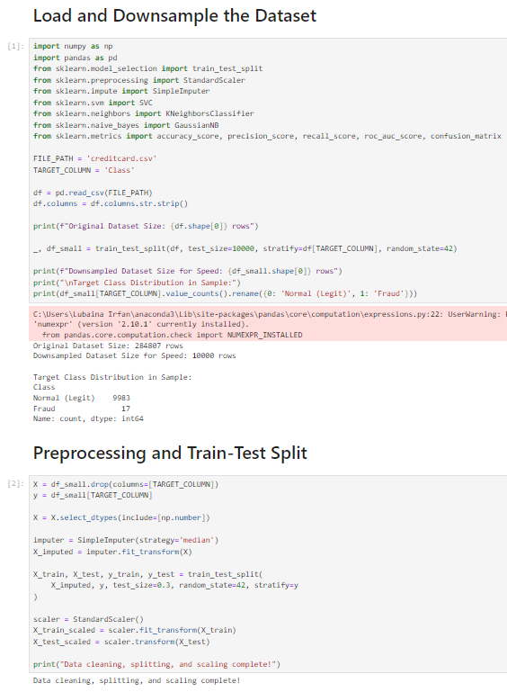
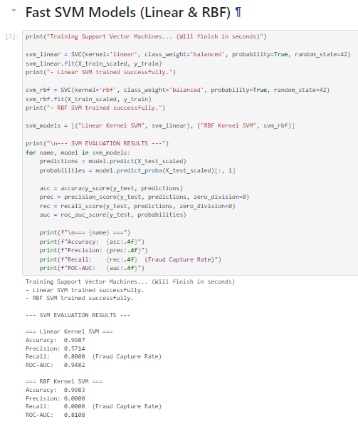
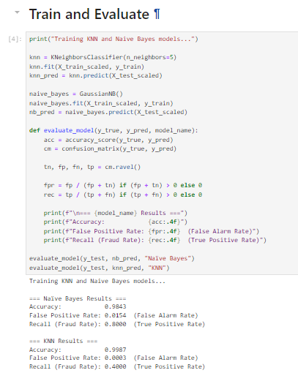

LAB-12
Clustering

1. Introduction
Clustering is an unsupervised machine learning technique used to group similar data points into clusters. Unlike supervised learning, clustering does not require labeled data. It identifies patterns and structures within the dataset based on similarity.
The main objective of clustering is to ensure that:
- Data points within the same cluster are highly similar
- Data points in different clusters are significantly different

2. Basic Concept
Clustering works by analyzing the distance or similarity between data points. Points that are close to each other are grouped into the same cluster, while distant points are placed in different clusters.

3. Types of Clustering

a) Partitioning Clustering
Divides the dataset into a fixed number of clusters.
Example: K-Means Algorithm
- Assigns data points to nearest cluster center (centroid)
- Updates centroids iteratively

b) Hierarchical Clustering
Builds clusters in a tree-like structure (dendrogram).
Types:
- Agglomerative (Bottom-Up): Each point starts as its own cluster and merges
- Divisive (Top-Down): Starts with one cluster and splits

c) Density-Based Clustering
Forms clusters based on dense regions of data.
Example: DBSCAN
- Groups points that are closely packed
- Identifies noise (outliers)

d) Grid-Based Clustering
Divides data space into grids and forms clusters based on grid density.

4. K-Means Clustering (Most Common)

Working Steps:
- Choose number of clusters (K)
- Initialize K centroids randomly
- Assign each data point to nearest centroid
- Update centroids based on assigned points
- Repeat until convergence

5. Distance Measures
Clustering relies on distance metrics such as:
- Euclidean Distance
- Manhattan Distance
- Cosine Similarity
These measures determine how similar or different data points are.

6. Evaluation Metrics
Since clustering is unsupervised, evaluation is done using:
- Inertia (Within-cluster sum of squares)
- Silhouette Score
- Davies-Bouldin Index

7. Advantages
- No need for labeled data
- Helps discover hidden patterns
- Useful for exploratory data analysis
- Can handle large datasets

8. Disadvantages
- Choosing number of clusters (K) can be difficult
- Sensitive to noise and outliers
- Results may vary depending on initialization
- Interpretation of clusters can be subjective

9. Applications
- Customer segmentation
- Image segmentation
- Market analysis
- Anomaly detection
- Document clustering

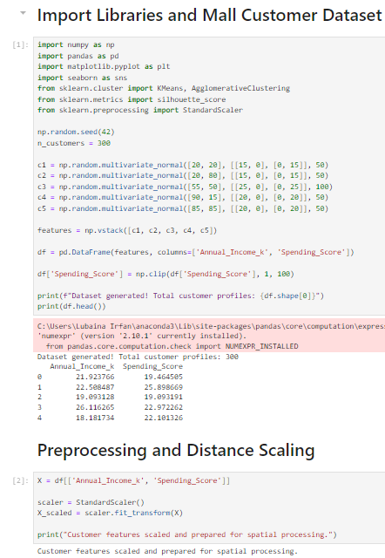
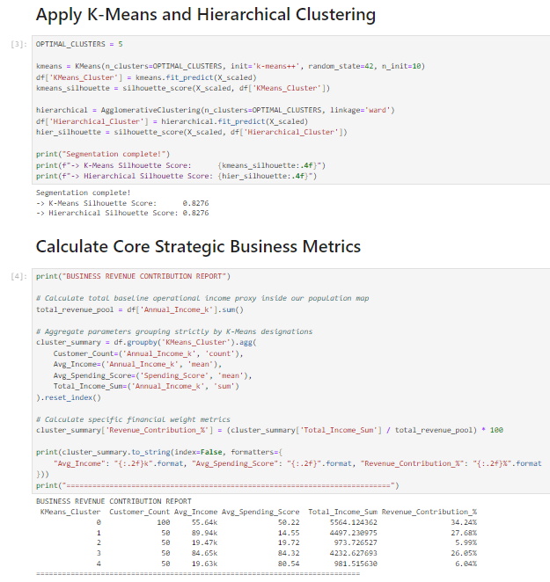
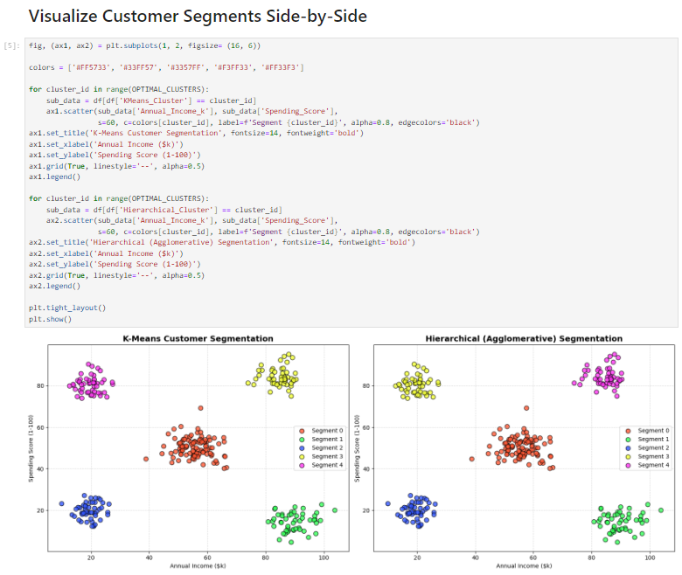

LAB-13
Outlier Detection

1. Introduction
Outlier Detection is a technique used to identify data points that significantly differ from the majority of the dataset. These unusual data points are called outliers or anomalies.
Outliers may occur due to:
- Measurement errors
- Data entry mistakes
- Rare events
- Natural variations in data
Detecting outliers is important because they can affect model performance and lead to incorrect conclusions.

2. Basic Concept
Outliers are observations that:
- Lie far away from other data points
- Do not follow the general pattern of the dataset
Outlier detection helps in:
- Improving data quality
- Enhancing model accuracy
- Detecting fraud or unusual behavior

3. Types of Outliers

a) Point Outliers
A single data point that is far from the rest.

b) Contextual Outliers
A data point that is abnormal in a specific context (e.g., temperature in winter vs summer).

c) Collective Outliers
A group of data points that together behave abnormally.

4. Methods of Outlier Detection

a) Statistical Methods
These methods assume a distribution of data.
- Z-Score Method
Measures how far a point is from the mean:
[
Z = \frac{X - \mu}{\sigma}
]
If |Z| > 3 → Outlier
- IQR (Interquartile Range) Method
[
IQR = Q3 - Q1
]
Outlier if:
  - (X < Q1 - 1.5 \times IQR)
  - (X > Q3 + 1.5 \times IQR)

b) Distance-Based Methods
- Measure distance between data points
- Points far from others are considered outliers

c) Density-Based Methods
- Identify regions of low density
- Example: DBSCAN, LOF (Local Outlier Factor)

d) Machine Learning Methods
- Use algorithms to detect anomalies
- Examples:
  - Isolation Forest
  - One-Class SVM

5. Working Steps
- Collect and preprocess data
- Choose an outlier detection method
- Calculate scores (distance, density, or statistical)
- Set threshold for identifying outliers
- Remove or analyze detected outliers

6. Advantages
- Improves data quality
- Enhances model accuracy
- Helps detect fraud and anomalies
- Useful in data preprocessing

7. Disadvantages
- Difficult to define exact threshold
- Risk of removing valid data
- Sensitive to dataset size and distribution

8. Applications
- Fraud detection (banking, credit cards)
- Network intrusion detection
- Medical diagnosis
- Quality control in manufacturing
- Data preprocessing
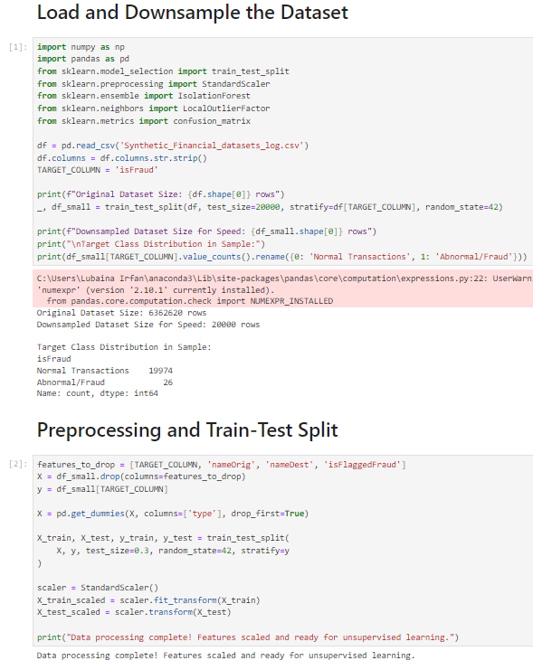
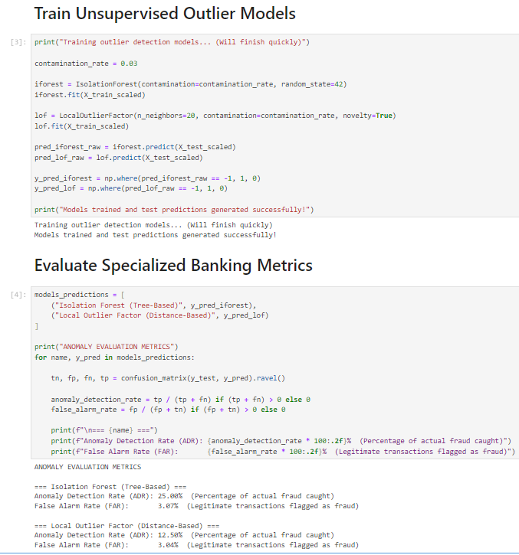

LAB-14
Scraping & Sentiment Analysis

1. Introduction
Web Scraping and Sentiment Analysis are important techniques used in data collection and text analysis.
- Web Scraping is used to extract data from websites.
- Sentiment Analysis is used to analyze emotions or opinions from text data.
Together, they are widely used in real-world applications like product reviews, social media analysis, and market research.

2. Web Scraping

Definition
Web Scraping is the process of automatically extracting data from websites using software tools or scripts.

Working Principle
- Send a request to a webpage (using HTTP request)
- Retrieve HTML content
- Parse HTML to extract required data
- Store the extracted data (CSV, database, etc.)

Common Tools & Libraries
- BeautifulSoup (Python)
- Scrapy
- Selenium
- Requests library

Advantages
- Automates data collection
- Saves time and effort
- Useful for large-scale data gathering

Disadvantages
- Websites may block scraping
- Requires handling dynamic content
- Legal and ethical issues must be considered

Applications
- Price comparison
- News aggregation
- Job listings collection
- Social media data extraction

3. Sentiment Analysis

Definition
Sentiment Analysis is a Natural Language Processing (NLP) technique used to determine whether a piece of text expresses positive, negative, or neutral sentiment.

Working Principle
- Collect text data (e.g., reviews, tweets)
- Clean and preprocess text (remove stopwords, punctuation)
- Convert text into numerical form (vectorization)
- Apply machine learning or NLP techniques
- Classify sentiment (positive/negative/neutral)

Types of Sentiment Analysis
- Fine-grained Sentiment Analysis (e.g., very positive, positive, neutral)
- Aspect-based Sentiment Analysis (focuses on specific features)
- Emotion Detection (happy, sad, angry, etc.)

Techniques Used
- Lexicon-based methods (dictionary of words with sentiment scores)
- Machine Learning methods (Naïve Bayes, SVM, etc.)
- Deep Learning methods (LSTM, BERT)

Advantages
- Helps understand customer opinions
- Useful for decision-making
- Can process large volumes of text

Disadvantages
- Difficult to detect sarcasm and context
- Requires preprocessing
- Accuracy depends on model and data quality

Applications
- Product review analysis
- Social media monitoring
- Brand reputation management
- Customer feedback analysis

4. Integration of Web Scraping & Sentiment Analysis
These two techniques are often used together:
- Scrape data from websites (e.g., reviews, tweets)
- Analyze sentiment of collected data
- Generate insights (e.g., customer satisfaction level)

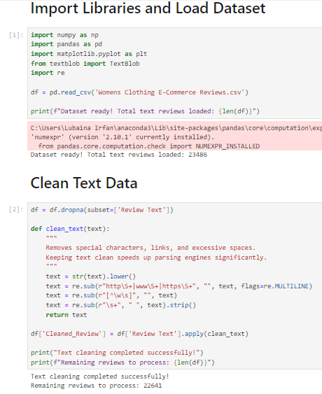
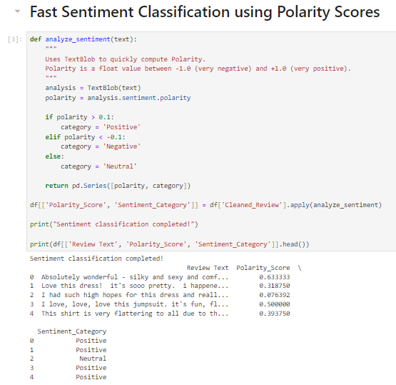
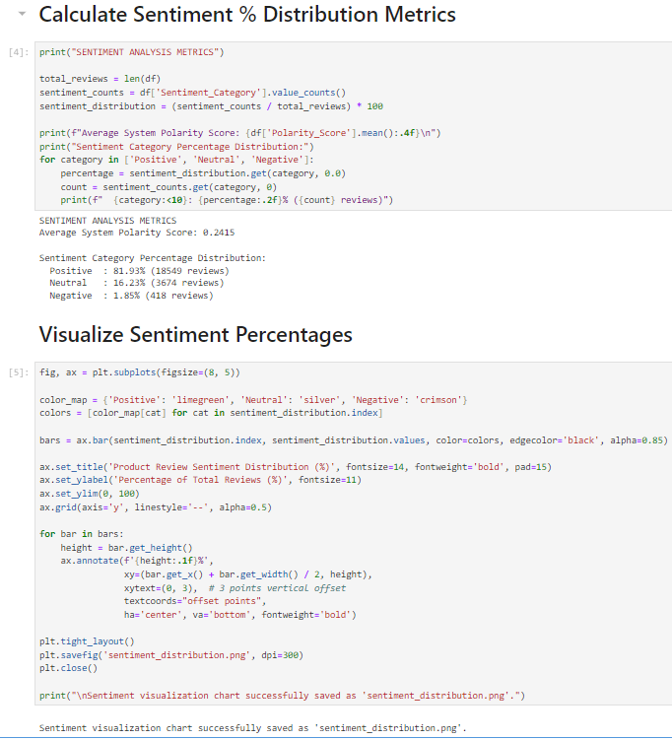

LAB-15
Final Capstone

1. Introduction
A Final Capstone Project is a comprehensive project that integrates all the concepts, tools, and techniques learned throughout the course. It allows students to apply theoretical knowledge to solve a real-world problem.
The capstone project demonstrates skills in:
- Data collection
- Data preprocessing
- Model building
- Evaluation and analysis

2. Objective
The main objectives of the capstone project are:
- To apply machine learning concepts in a practical scenario
- To develop problem-solving and analytical skills
- To build an end-to-end working system
- To evaluate and compare different models

3. Project Workflow
A typical capstone project follows these steps:

1. Problem Definition
- Identify a real-world problem
- Define clear objectives and expected outcomes

2. Data Collection
- Gather data from sources such as:
  - Datasets (CSV, Kaggle, etc.)
  - Web scraping
  - APIs

3. Data Preprocessing
- Handle missing values
- Remove noise and outliers
- Convert data into suitable format
- Feature selection and extraction

4. Exploratory Data Analysis (EDA)
- Understand data patterns
- Visualize trends and relationships
- Identify important features

5. Model Building
- Apply machine learning algorithms such as:
  - Naïve Bayes
  - KNN
  - SVM
  - Clustering techniques

6. Model Evaluation
- Evaluate performance using metrics:
  - Accuracy
  - Precision
  - Recall
  - F1-score
  - False Positive Rate

7. Comparison of Models
- Compare multiple models
- Select the best-performing model

8. Deployment (Optional)
- Implement the model in a real application
- Create a user interface (web app, dashboard, etc.)

4. Tools & Technologies
Common tools used:
- Python (Pandas, NumPy, Scikit-learn)
- RapidMiner / KNIME
- Jupyter Notebook
- Visualization libraries (Matplotlib, Seaborn)

5. Expected Outcomes
- A working machine learning model
- Performance comparison of algorithms
- Visualizations and insights
- Final report and presentation

6. Advantages
- Practical understanding of concepts
- Hands-on experience with real data
- Improves coding and analytical skills
- Prepares for industry-level projects

7. Challenges
- Data quality issues
- Model selection difficulty
- Overfitting or underfitting
- Time management

8. Applications
Capstone projects can be based on:
- Spam detection
- Sentiment analysis
- Customer segmentation
- Fraud detection
- Recommendation systems
